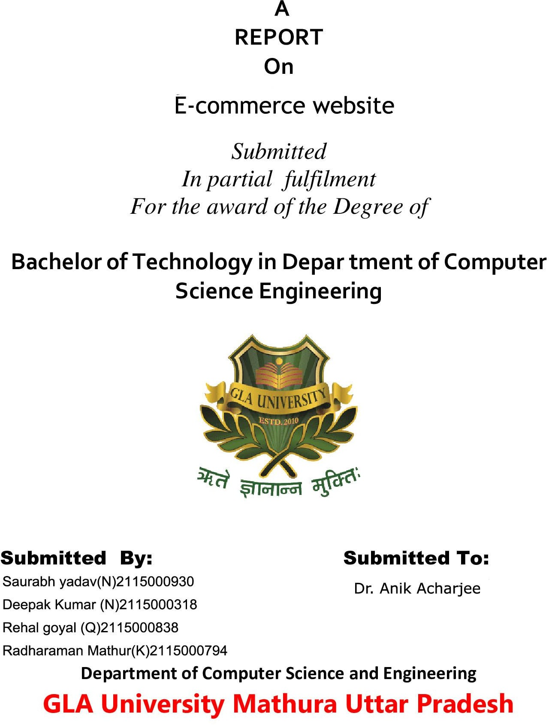

RAISING GROUND

Sarthak Dhangar [C]-2115000916 Dhruv Yadav [K]-2115000369 Adesh Yadav [B]-2115000051

Shaurya Dev Singh Sengar [L]- 2115000941

Mr. Ankit Arora

**Candidate's Declaration**

I hereby declare that the work, which is being presented in the Project Report, entitled "**Web Development with PHP"** in partial fulfilment for the award of Degree of Bachelor of Technology'' in Deptt. Of **Computer Science and Engineering** and submitted to the Department of **Computer Science and Engineering, GLA University,** is a record of my own investigations

carried under the Guidance of

### Engineering, GLA University

**Mr.Ankit Arora**

Department of **Computer Science and**

I have not submitted the matter presented in this Project Report anywhere for the award of any other Degree.

### (Name and Signature of Candidates)

Sarthak Dhangar [C]-2115000916 Dhruv Yadav [K]-2115000369 Adesh Yadav [B]-2115000051

Shaurya Dev Singh Sengar [L]- 2115000941

### Counter Signed by

Mr. Ankit Arora

ACKNOWLEDGEMENT

It is my pleasure to be indebted to various people, who directly or indirectly contributed in the development of this work and who influenced our thinking, behavior and acts during the course of study.

We express our sincere gratitude to

### Mr. Ankit Arora

, for providing us an opportunity to

undergo this Project as the part of the curriculum.

We are thankful to

### Mr. Ankit Arora

for his support, cooperation, and motivation provided to

us during the training for constant inspiration, presence and blessings.

We would also like to thank our **H.O.D Mr.Rohit Agarwal** for her valuable suggestions which helps us lot in completion of this project.

We also extend our sincere appreciation to

### Mr. Ankit Arora

who provided his valuable

suggestions and precious time in accomplishing our Project report.

Lastly, we would like to thank the almighty and our parents for their moral support and friends with whom we shared our day-to-day experience and received lots of suggestions that improved our quality of work.

### Sarthak Dhangar [C]-2115000916 Dhruv Yadav [K]-2115000369 Adesh Yadav [B]-2115000051

**Shaurya Dev Singh Sengar [L]- 2115000941**

ABSTRACT

Our project is **E-commerce**. This is a website which helps people to find and buy all type of Nursery Product on internet. It is useful in the way that it makes an easier way to buy and sell Nursery product online. **E-commerce** is

an interactive RAISING GROUND solution providing users with an opportunity to buy and sell Nursery Product. **E-**

**commerce** is the first online platform which deals with new and old Nursery Product of all fields.

In this website we have basically 2 modules. The first module includes the customer module and second module includes admin module.

The customer have to register for any enquiry related to Nursery Product. The registered customer can view details of Nursery Product and he/she can buy or sell the Nursery Product of his/her need. He/she has to pay and will get home delivery.

The admin module contains the access of admin page on the website. The admin can change everything

in the website. He have the ability to add, delete, and update any information regarding the Nursery Product.

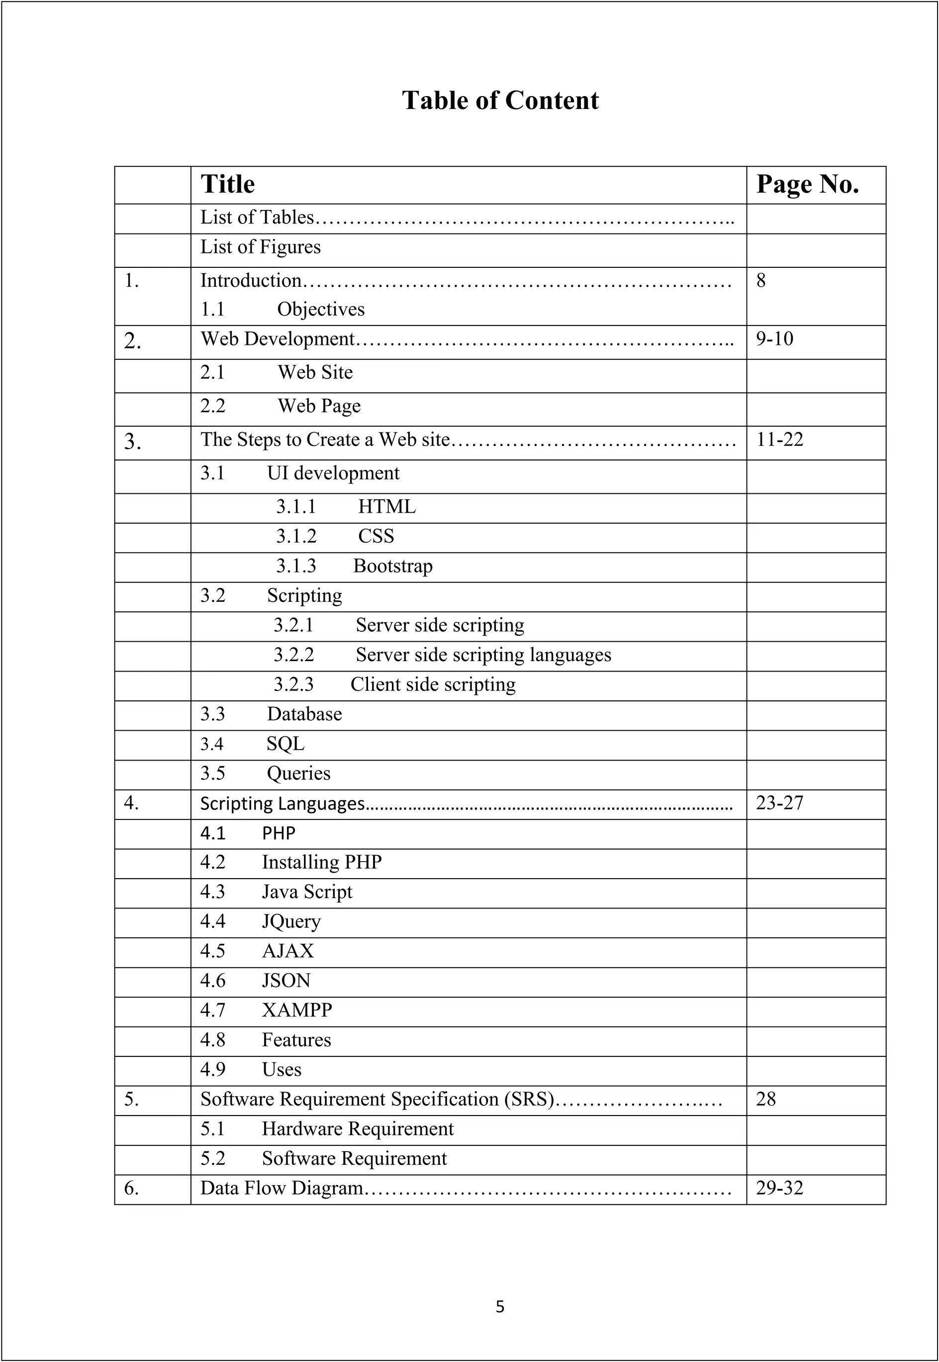

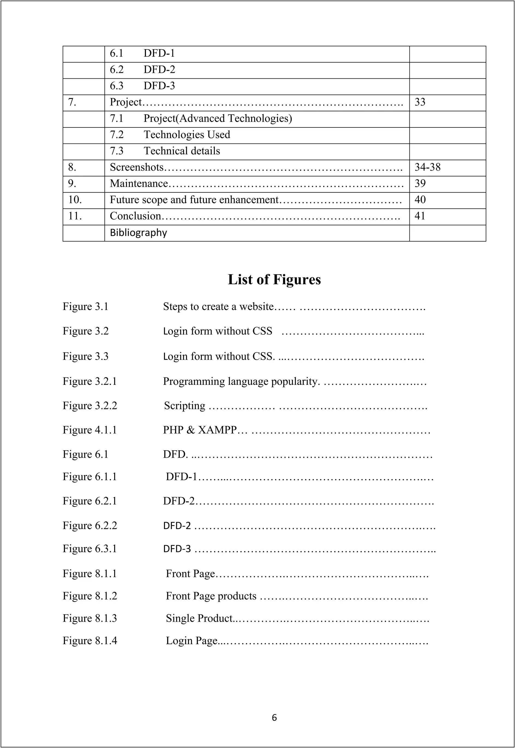



CHAPTER- I

### INTRODUCTION

Education, An integral part of our Indian Society and it is important for every individual to succeed in his life and help bring change to our world. In a country with more than 1.3 billion people living, for everyone individual education is essential. To keep learning and developing themselves and helping our environment, economy, social life be sustainable.

**E-commerce** is an interactive e-commerce solution providing users with an opportunity to buy and sell books. **E-commerce** is the first online platform which deals with new and old books of all fields, we deliver a constructive service to each and every person of Jammu & Kashmir to furnish their needs in terms of learning, education and technology by providing them with an online platform where they can Buy and sell books for affordable price and even they can sell their used books on our website and also get books on rent. **E-commerce** provides users with wide range of pre-owned books which get a check based on their condition and fixed to its best and delivered to consumer 's doorsteps.

# OBJECTIVES

The primary objective of the "Raising Ground" project is to create an online platform that simplifies the process of buying plants from nurseries. By offering a user-friendly interface, this website allows buyers to conveniently purchase plants from the comfort of their homes, thereby fostering a seamless connection between nurseries and plant enthusiasts.

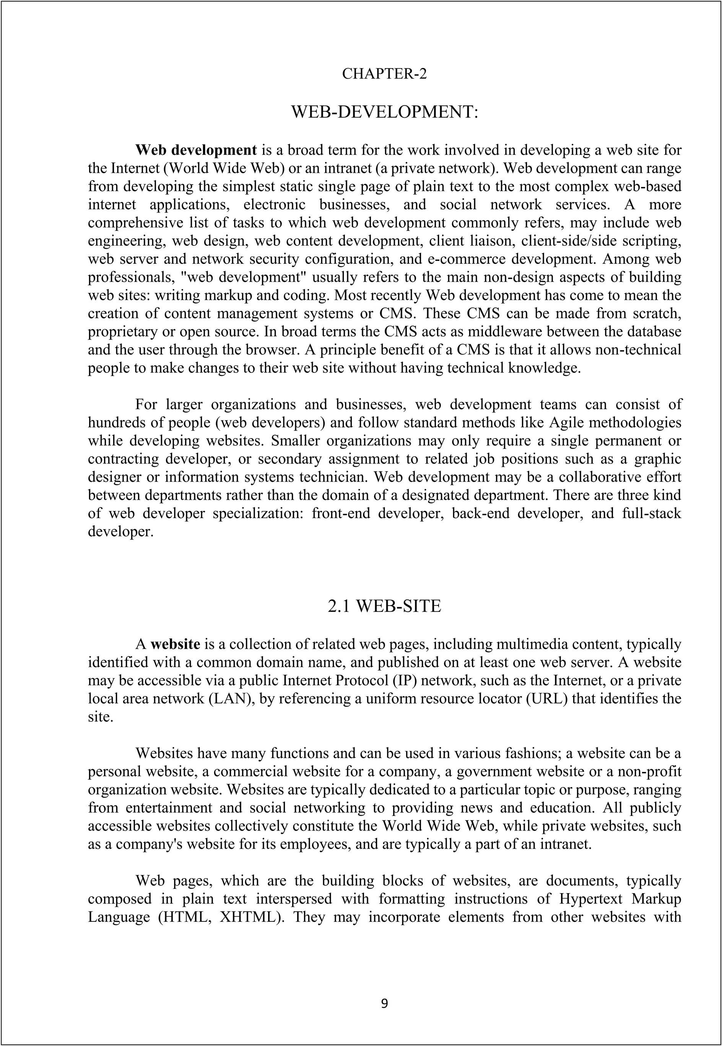

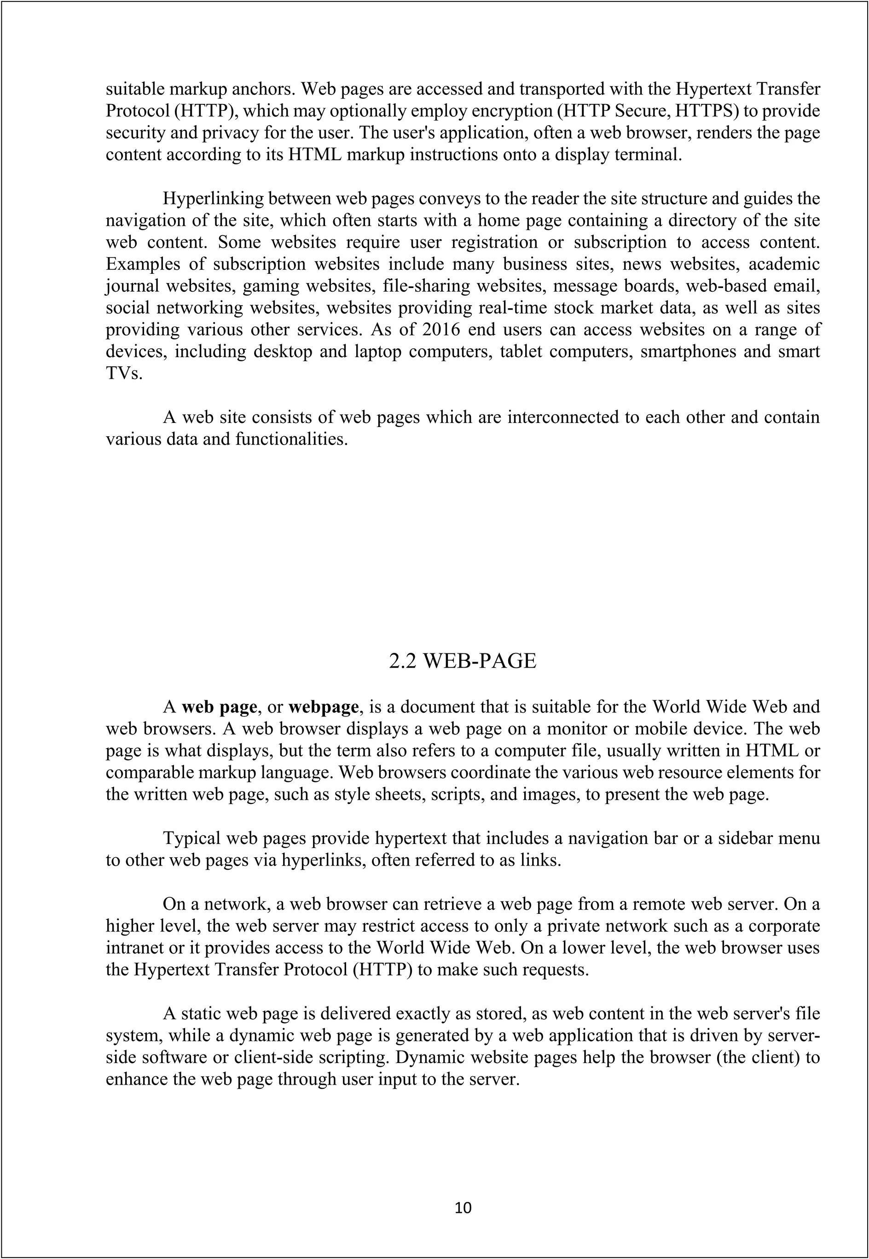

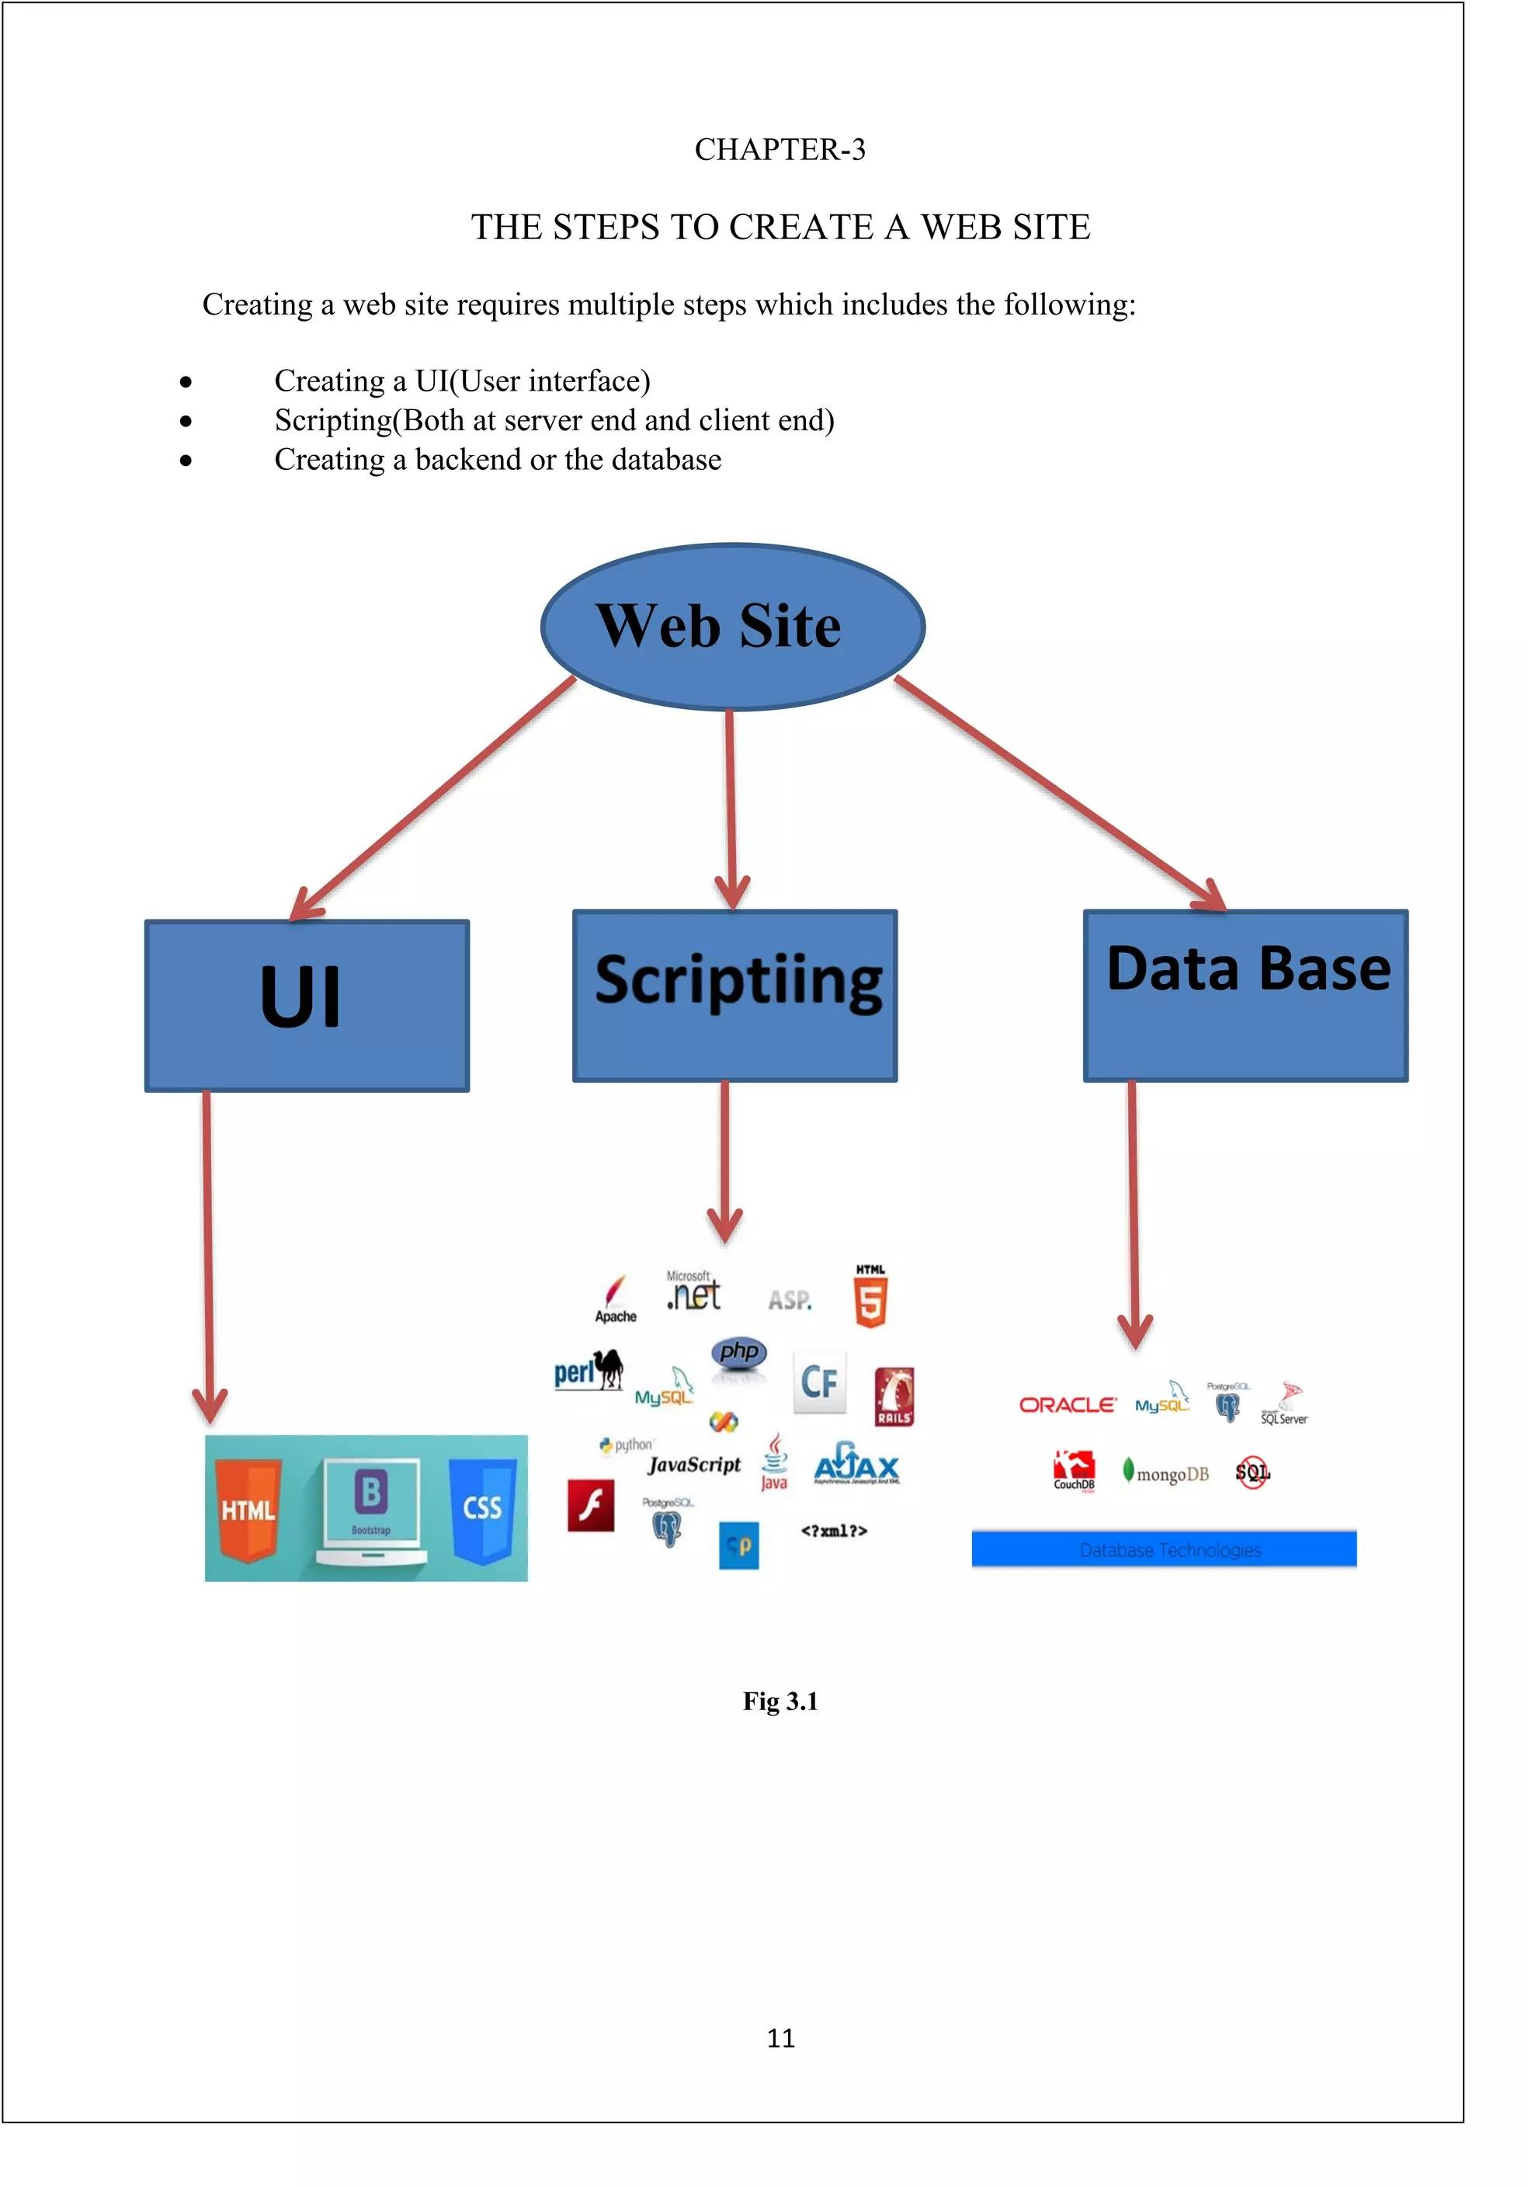

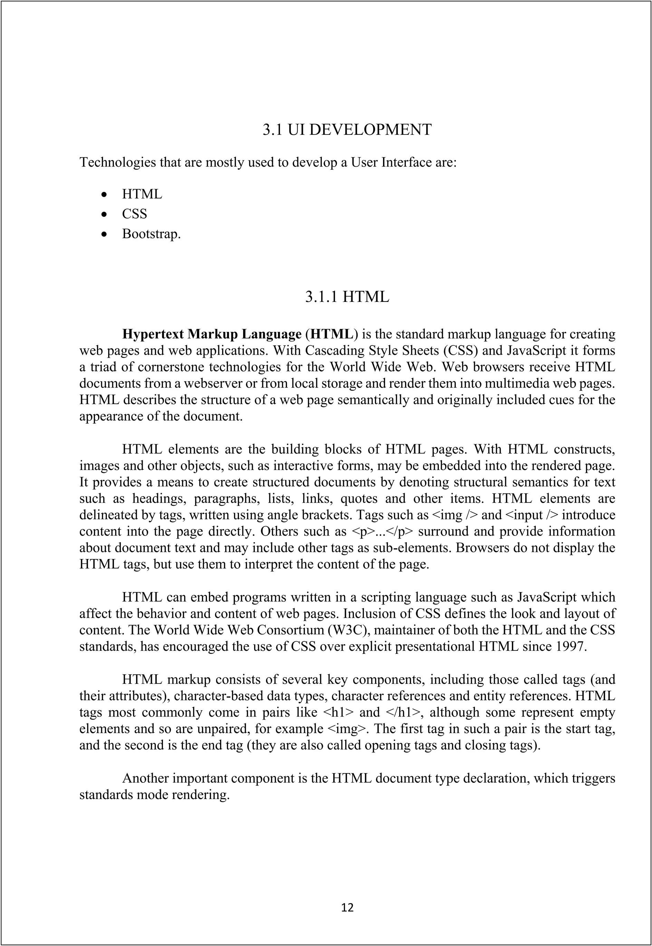

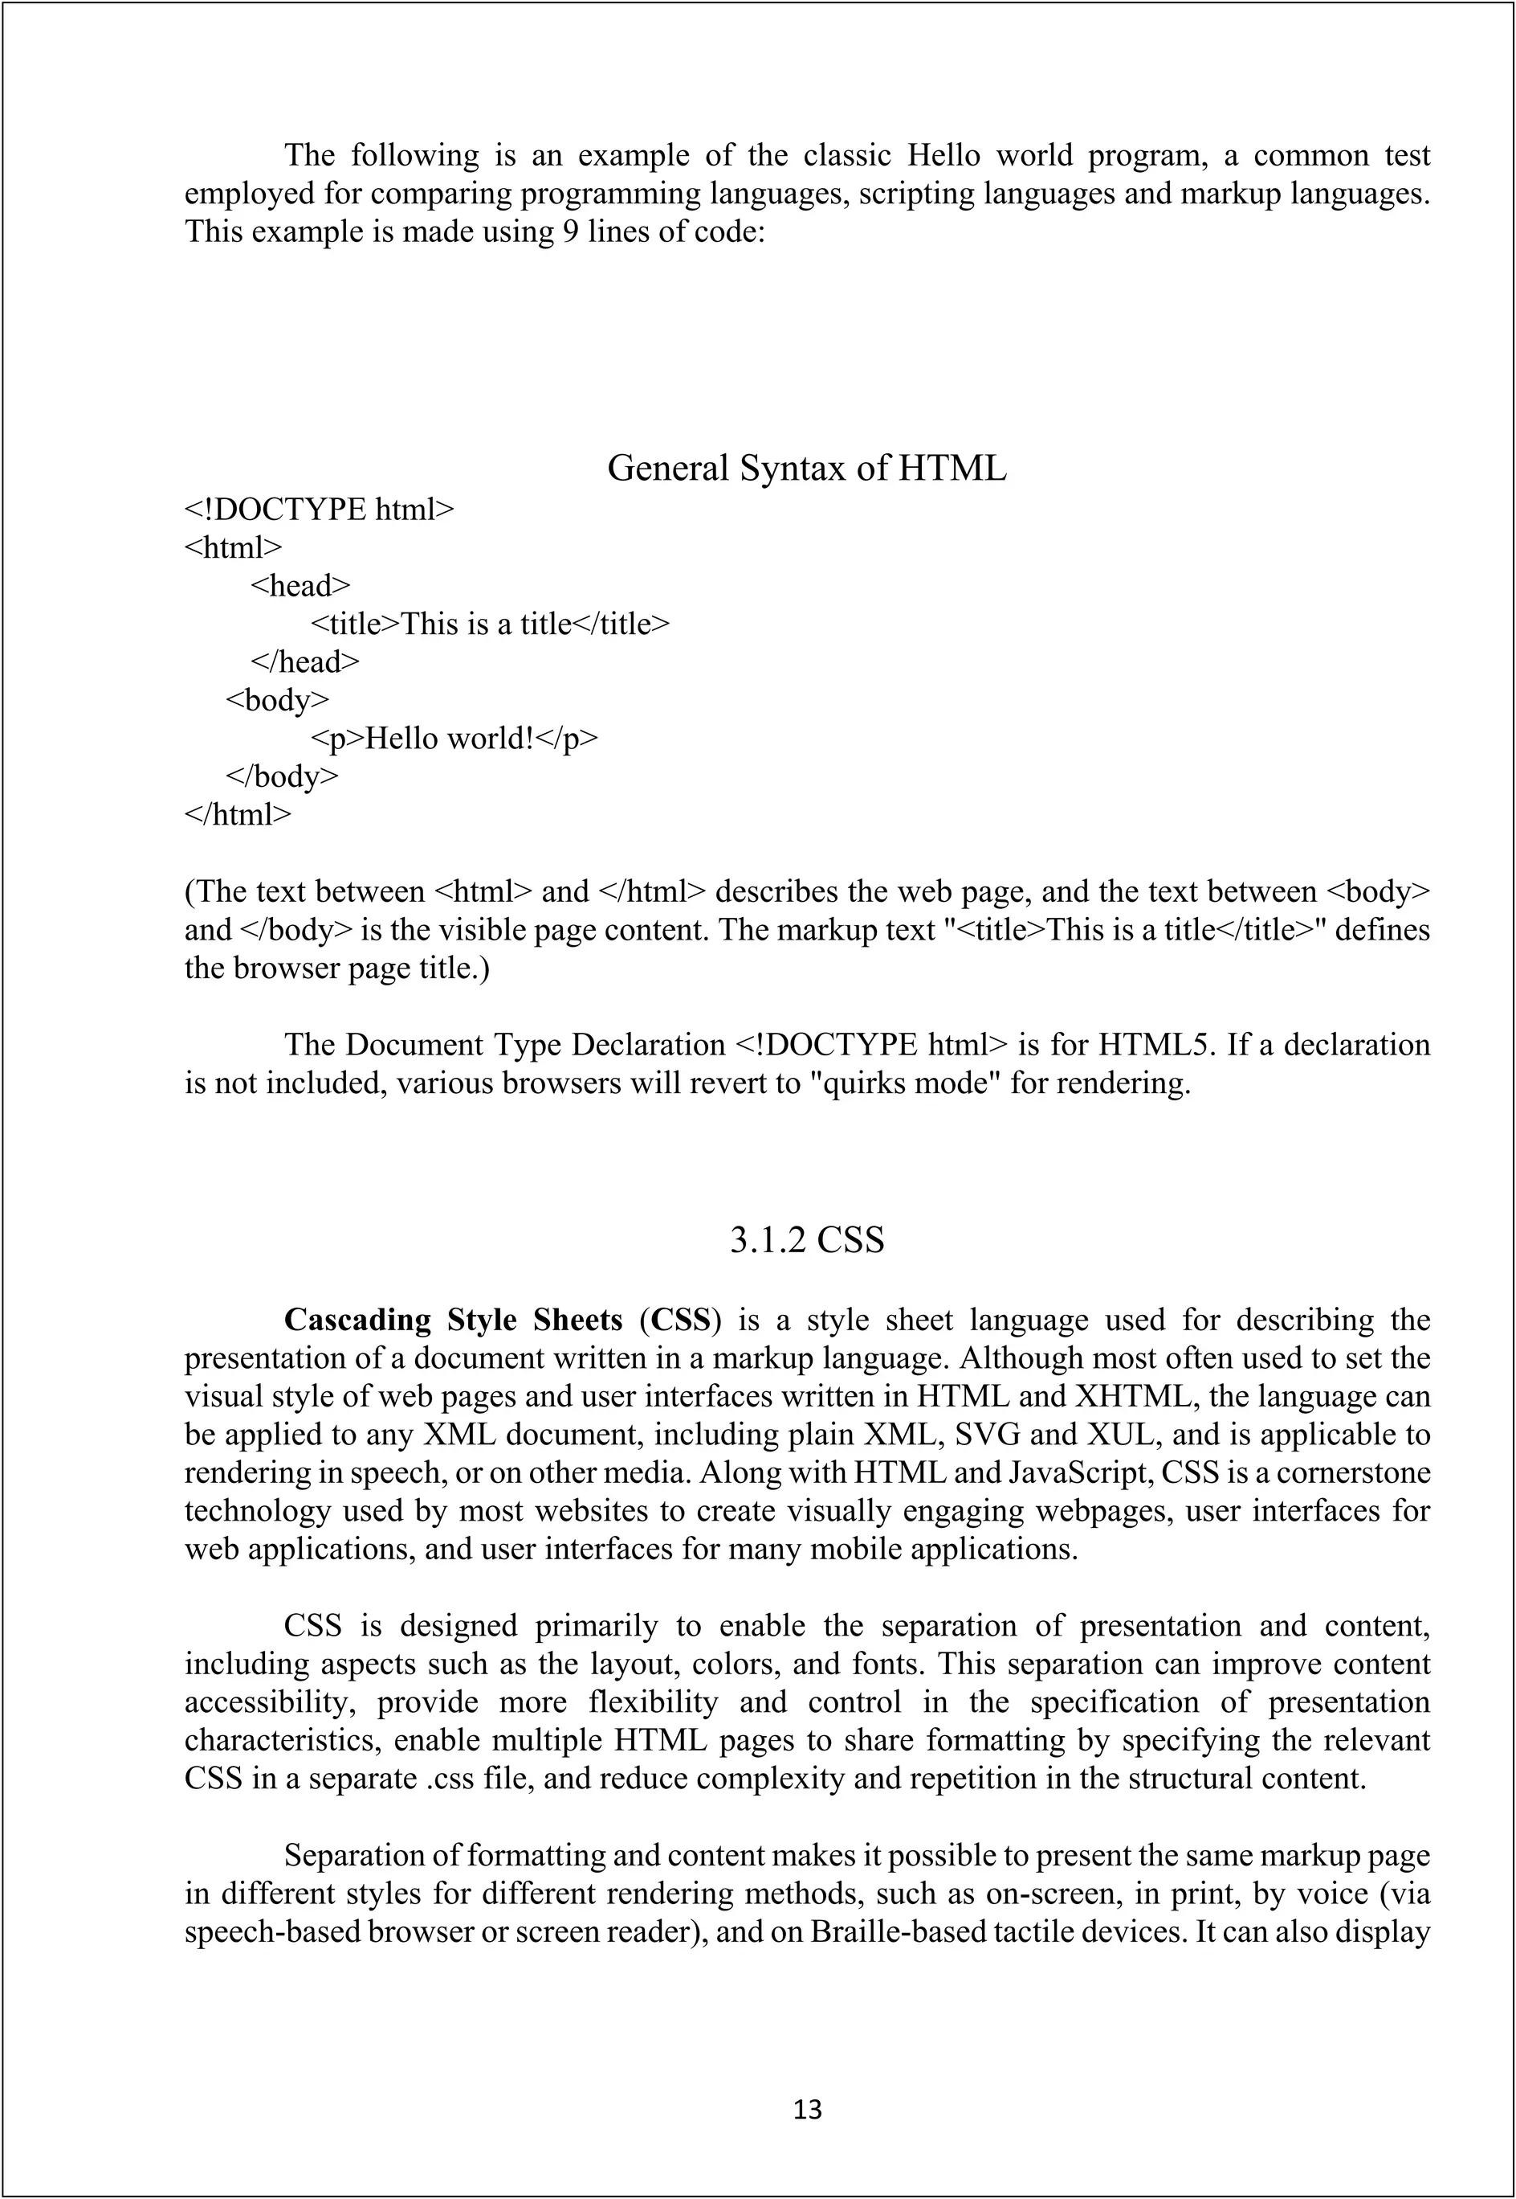

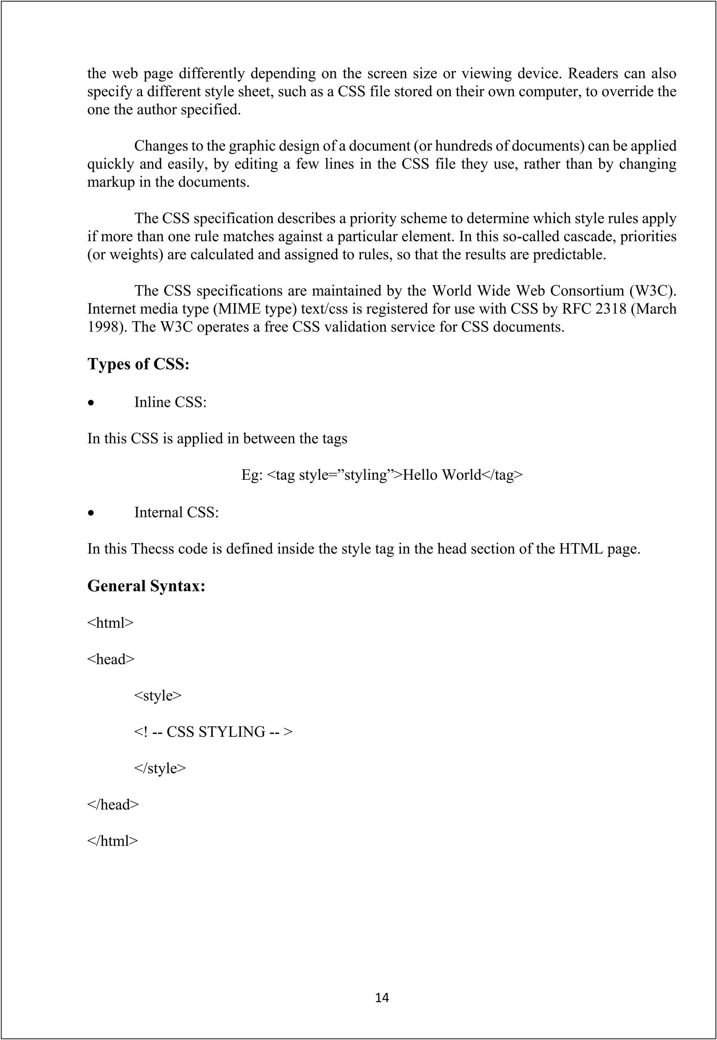

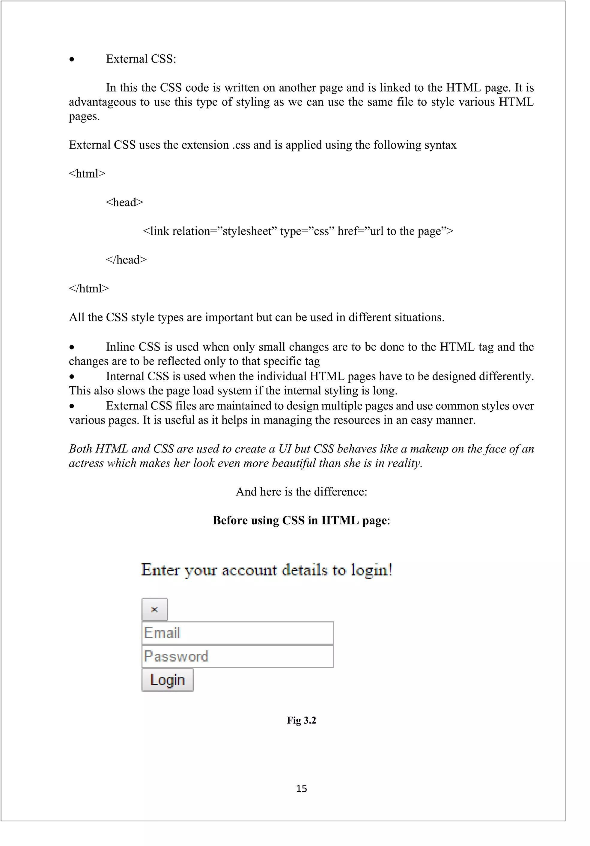

## After using CSS in HTML Page:

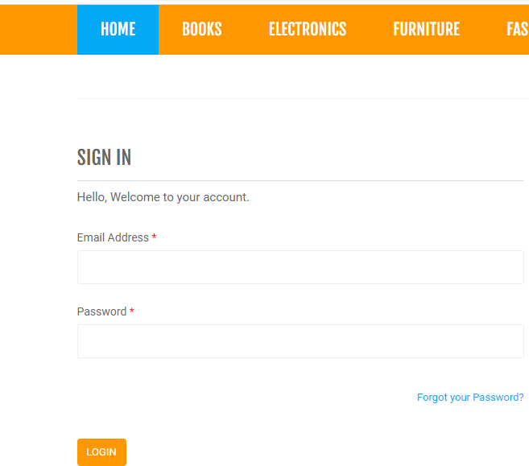

Fig 3.3

## 3.1.3 BOOTSTRAP

**Bootstrap** is a free and open-source front-end web framework for designing websites and web applications. It contains HTML- and CSS-based design templates for typography,forms, buttons, navigation and other interface components, as well as optional JavaScript extensions. Unlike many web frameworks, it concerns itself with front-end development only.

Bootstrap is the second most-starred project on GitHub, with more than 107,000 stars and 48,000 forks.

Bootstrap, originally named Twitter Blueprint, was developed by Mark Otto and Jacob Thornton at Twitter as a framework to encourage consistency across internal tools. Before Bootstrap, various libraries were used for interface development, which led to inconsistencies and a high maintenance burden. According to twitter developer Mark Otto:

A super small group of developers and I got together to design and build a new internal tool and saw an opportunity to do something more. Through that process, we saw ourselves build something much more substantial than another internal tool. Months later, we ended up with an early version of Bootstrap as a way to document and share common design patterns and assets within the company.

After a few months of development by a small group, many developers at Twitter began to contribute to the project as a part of Hack Week, a hackathon-style week for the Twitter development team. It was renamed from Twitter Blueprint to Bootstrap, and released as an

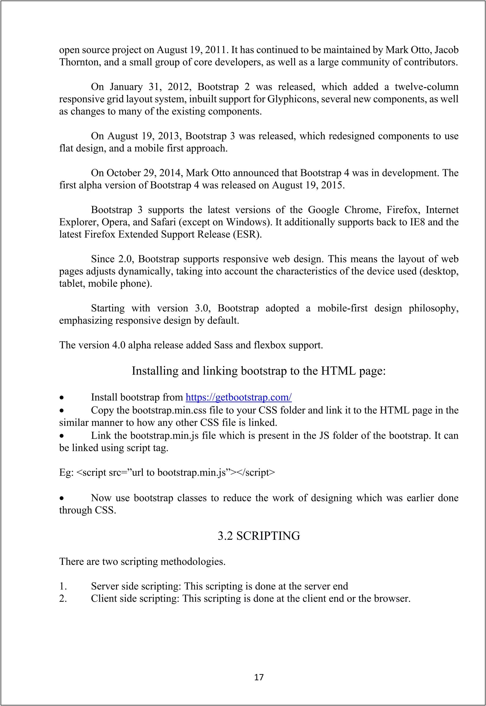

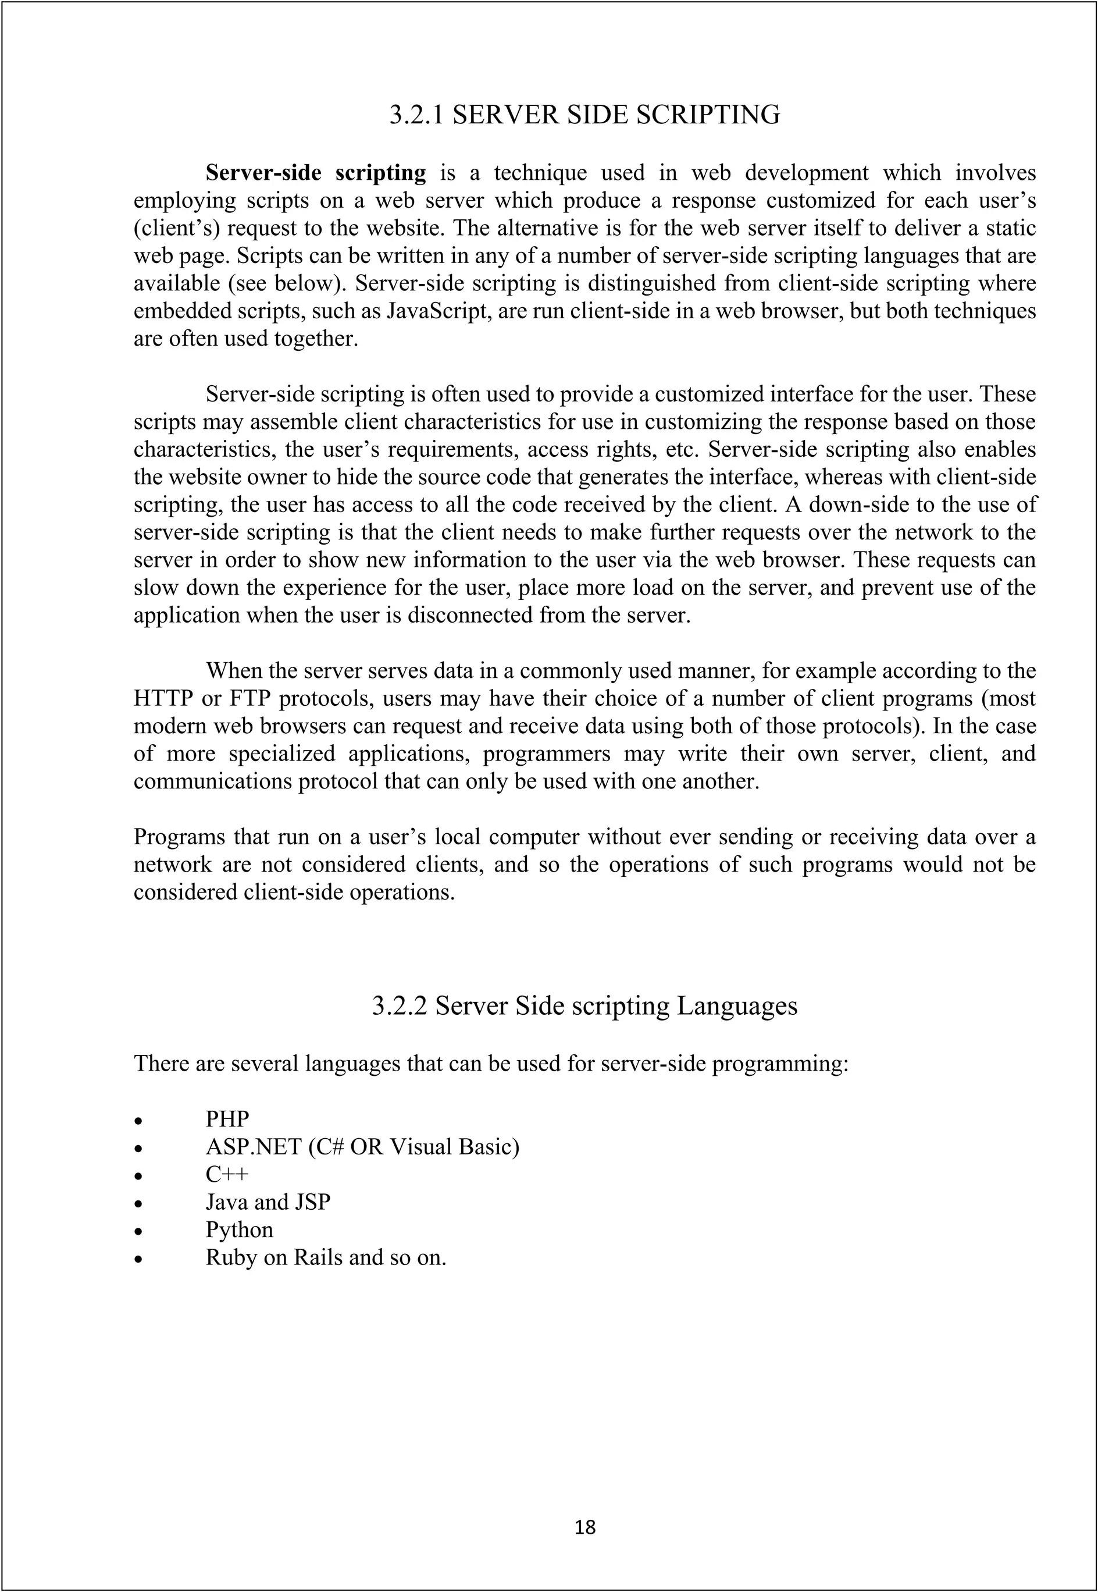

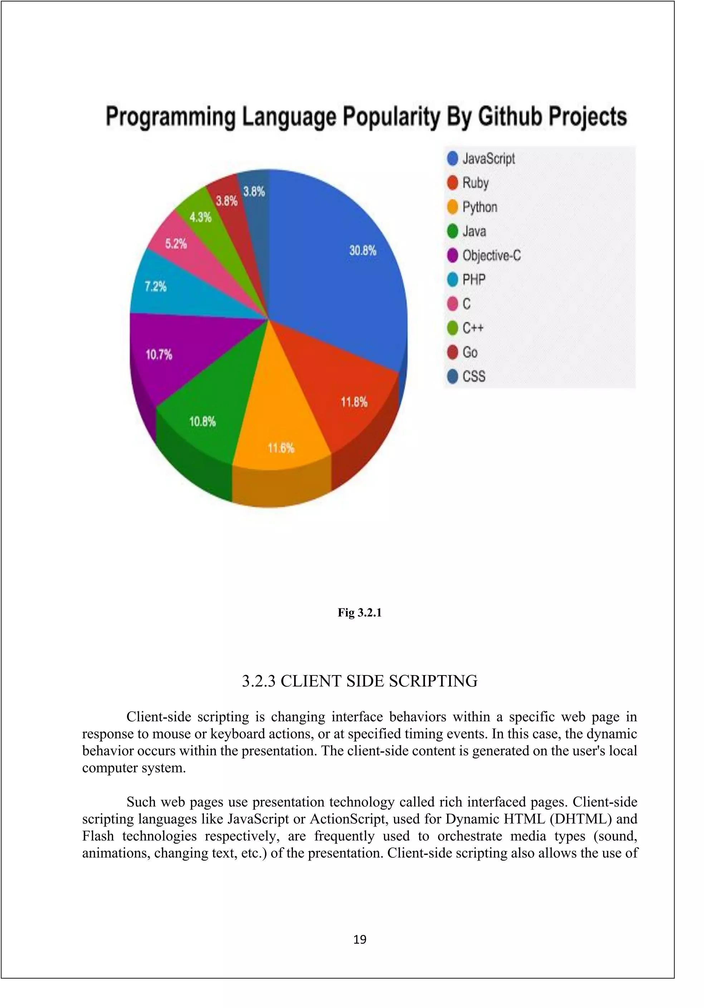

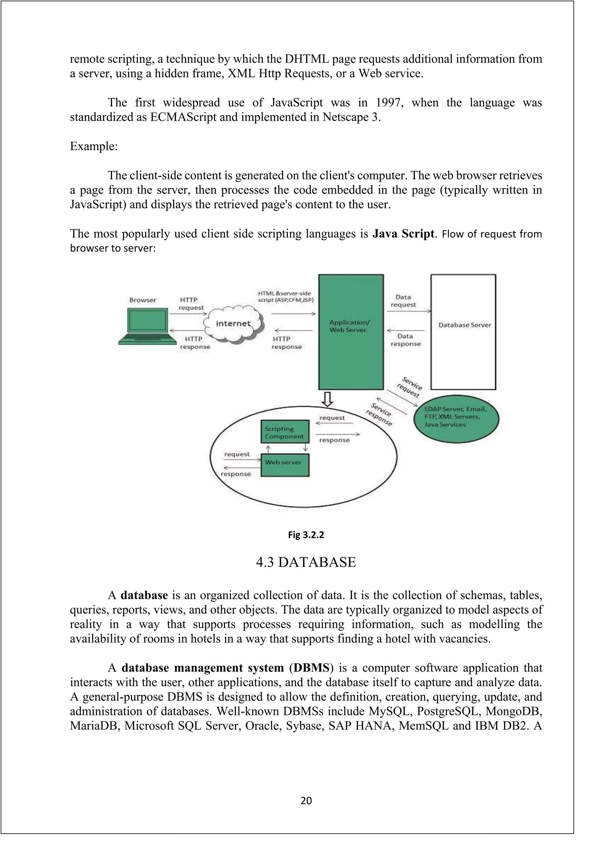

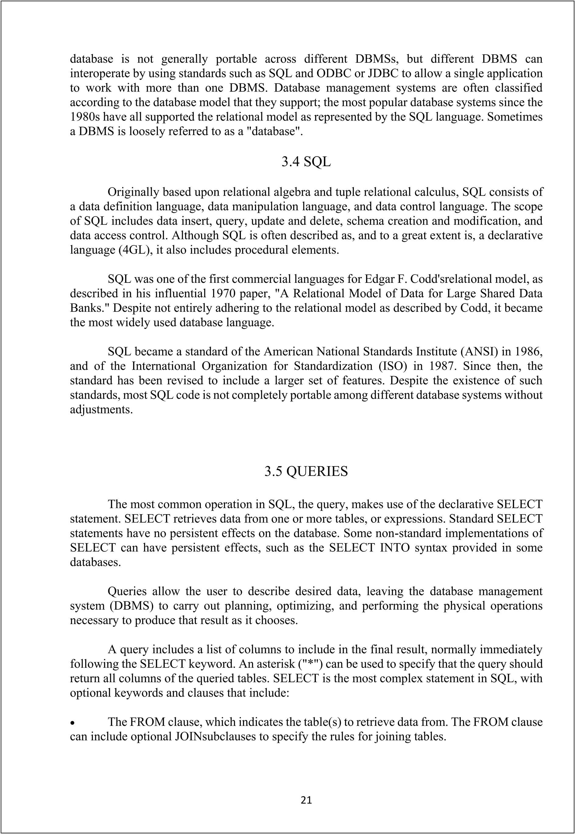



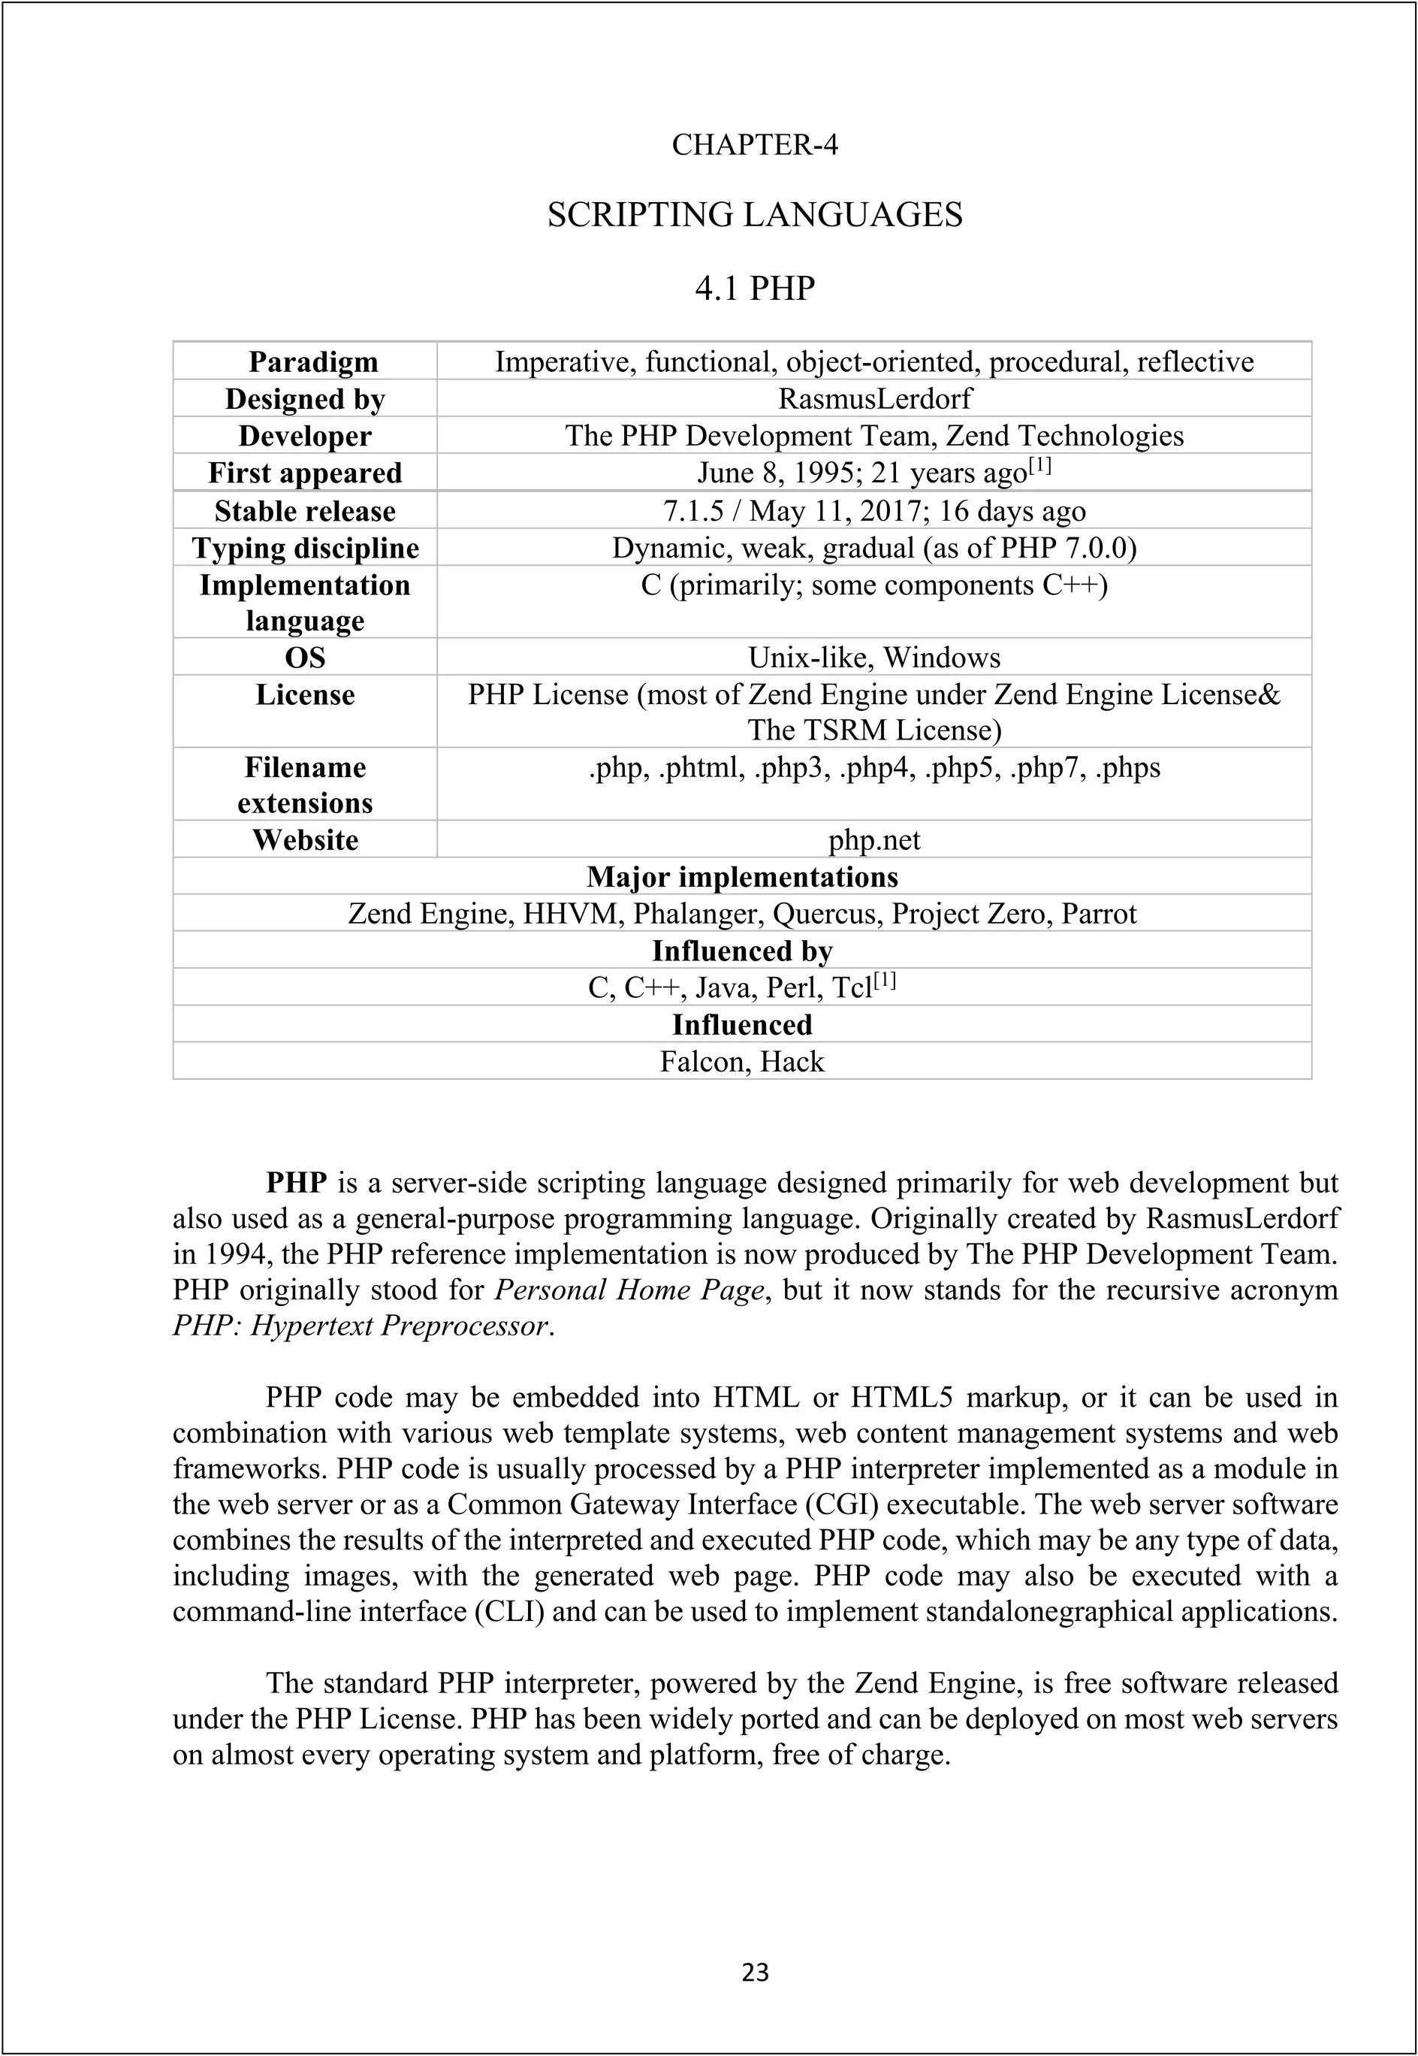

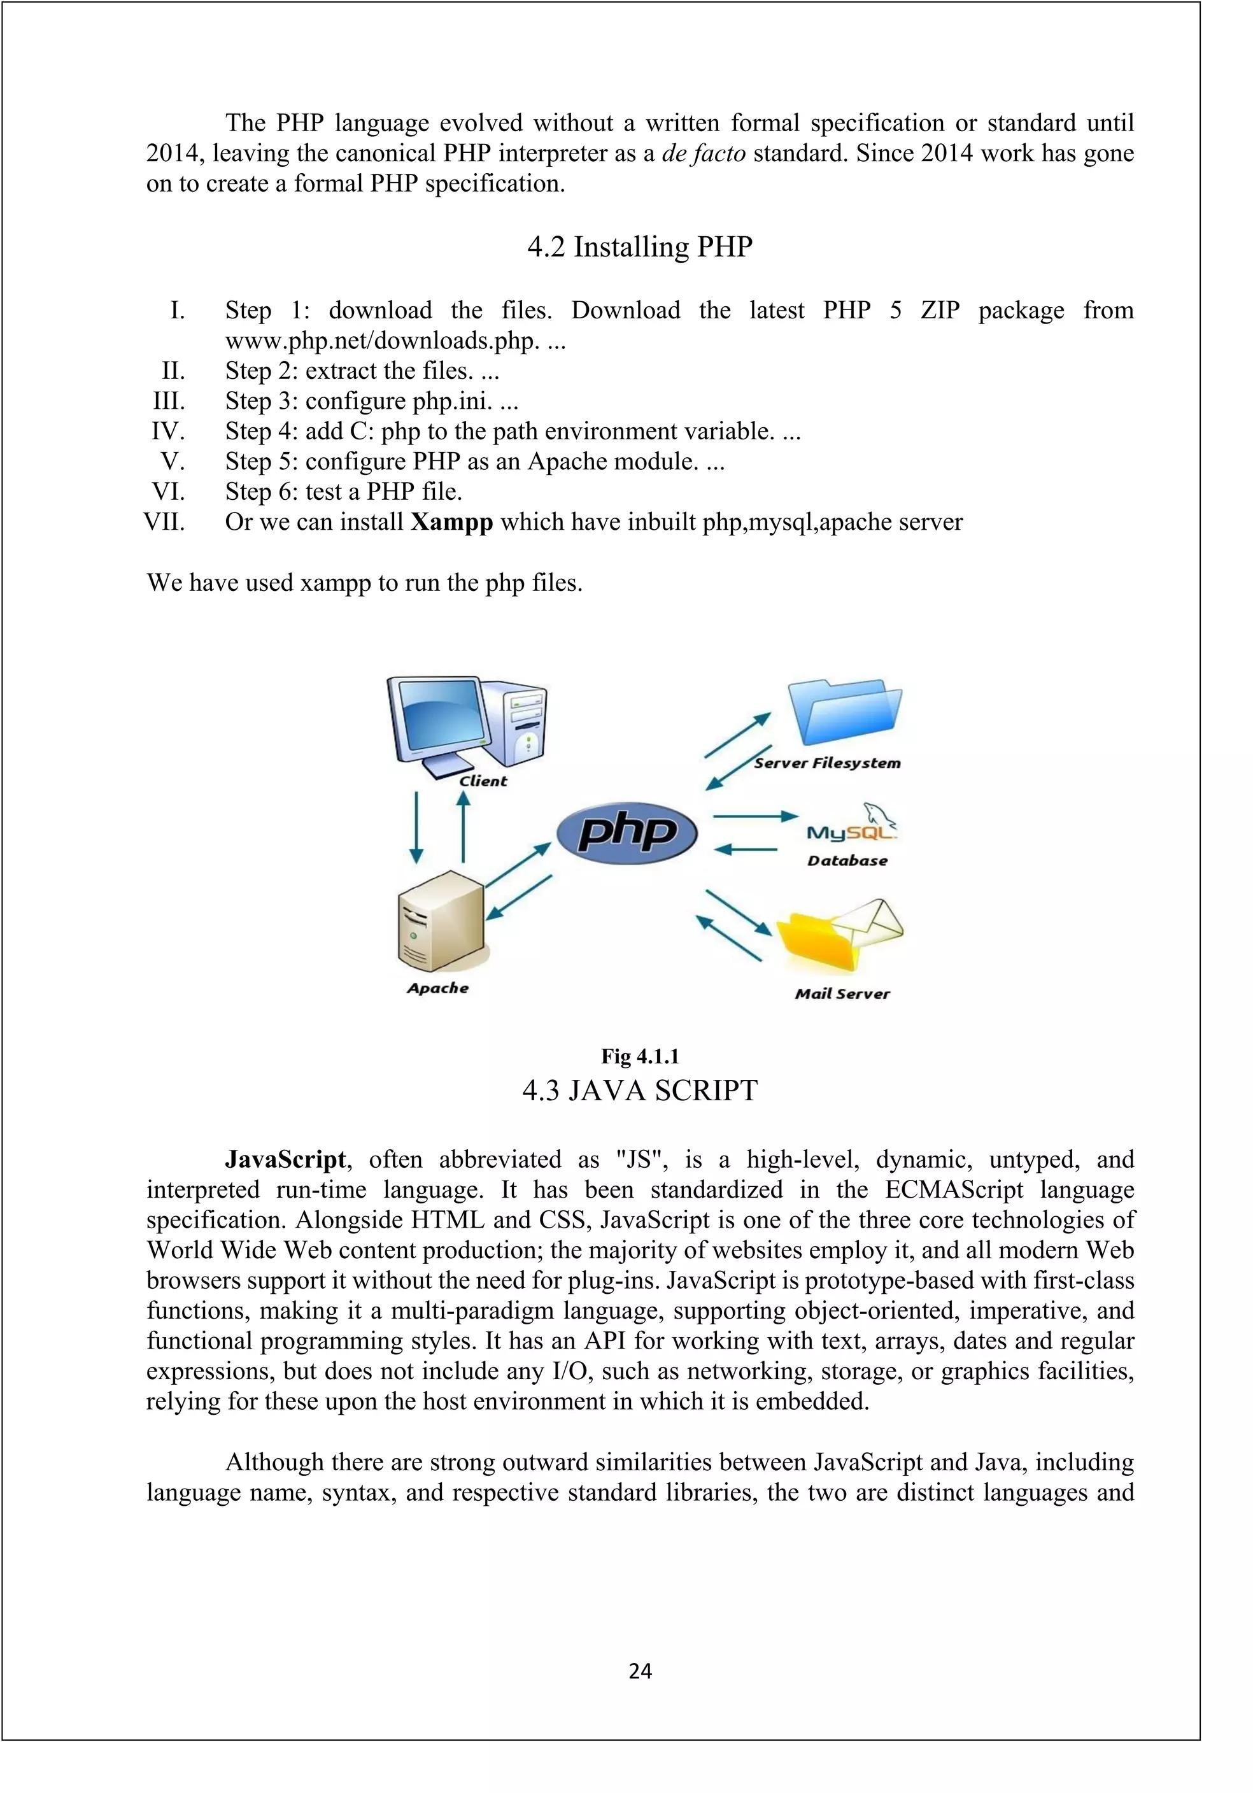

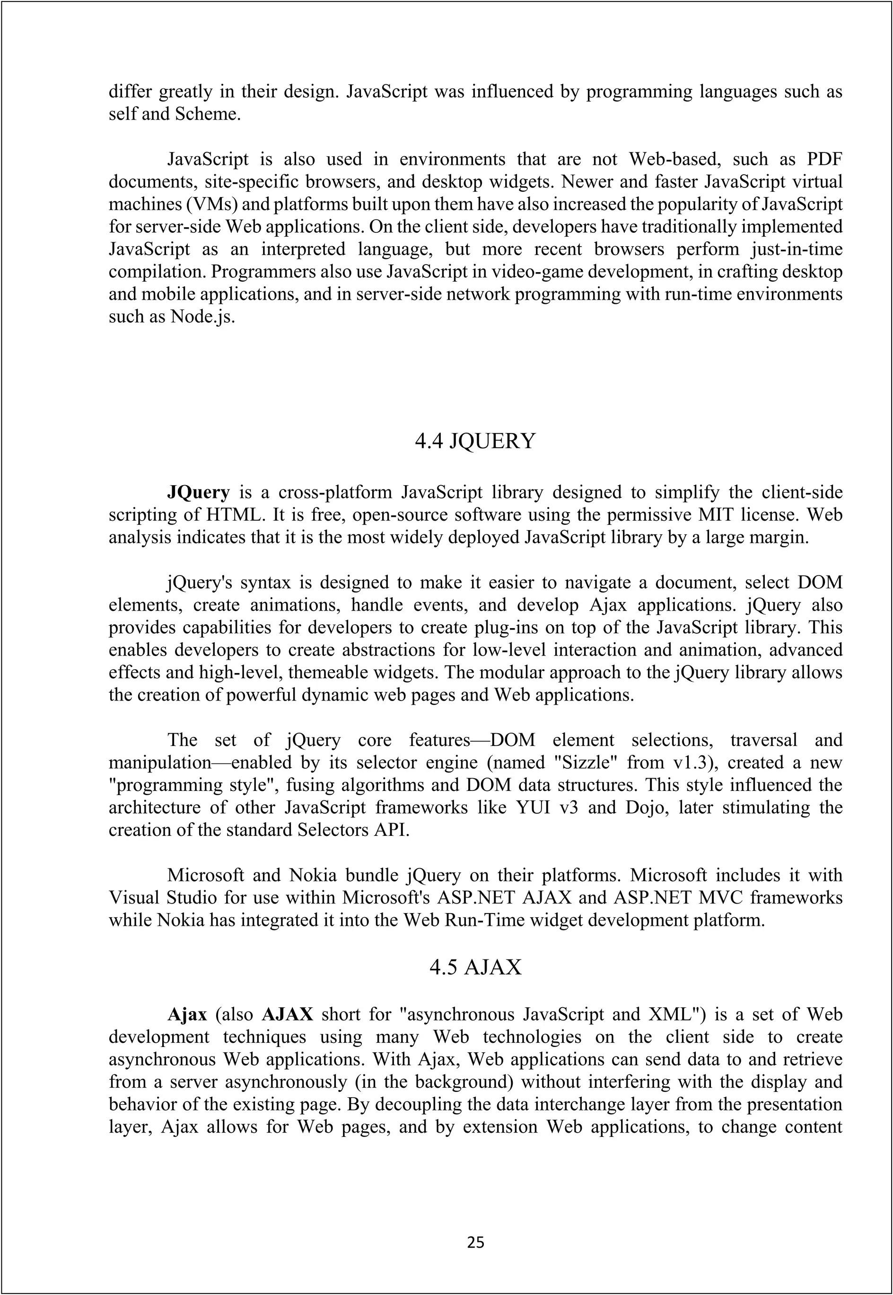

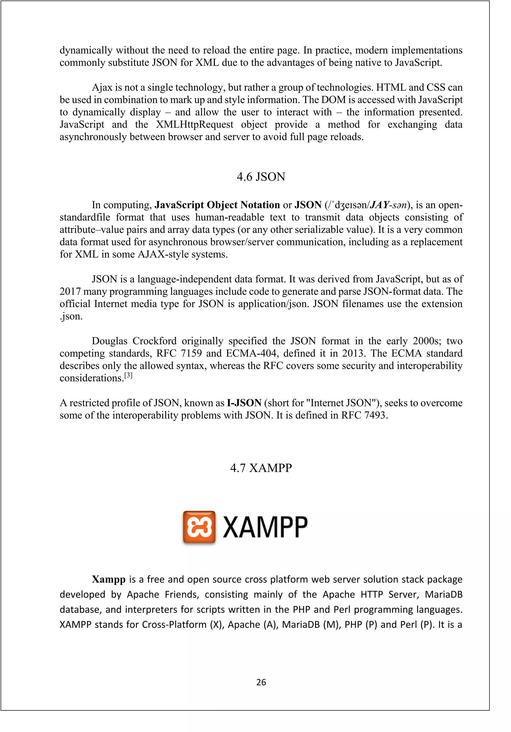

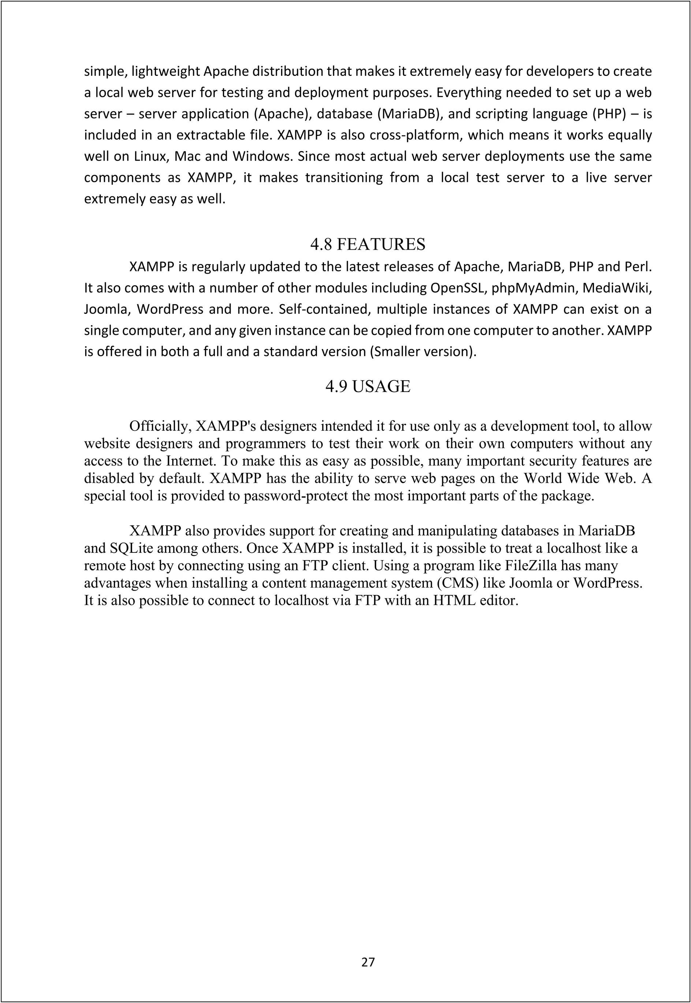

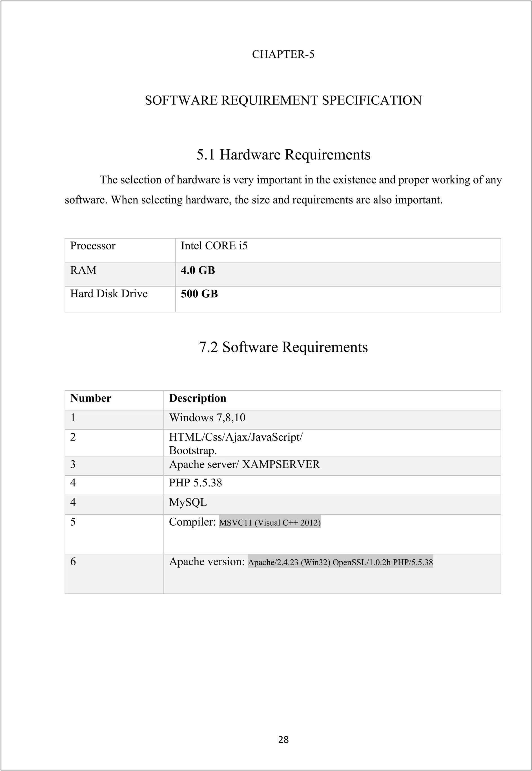

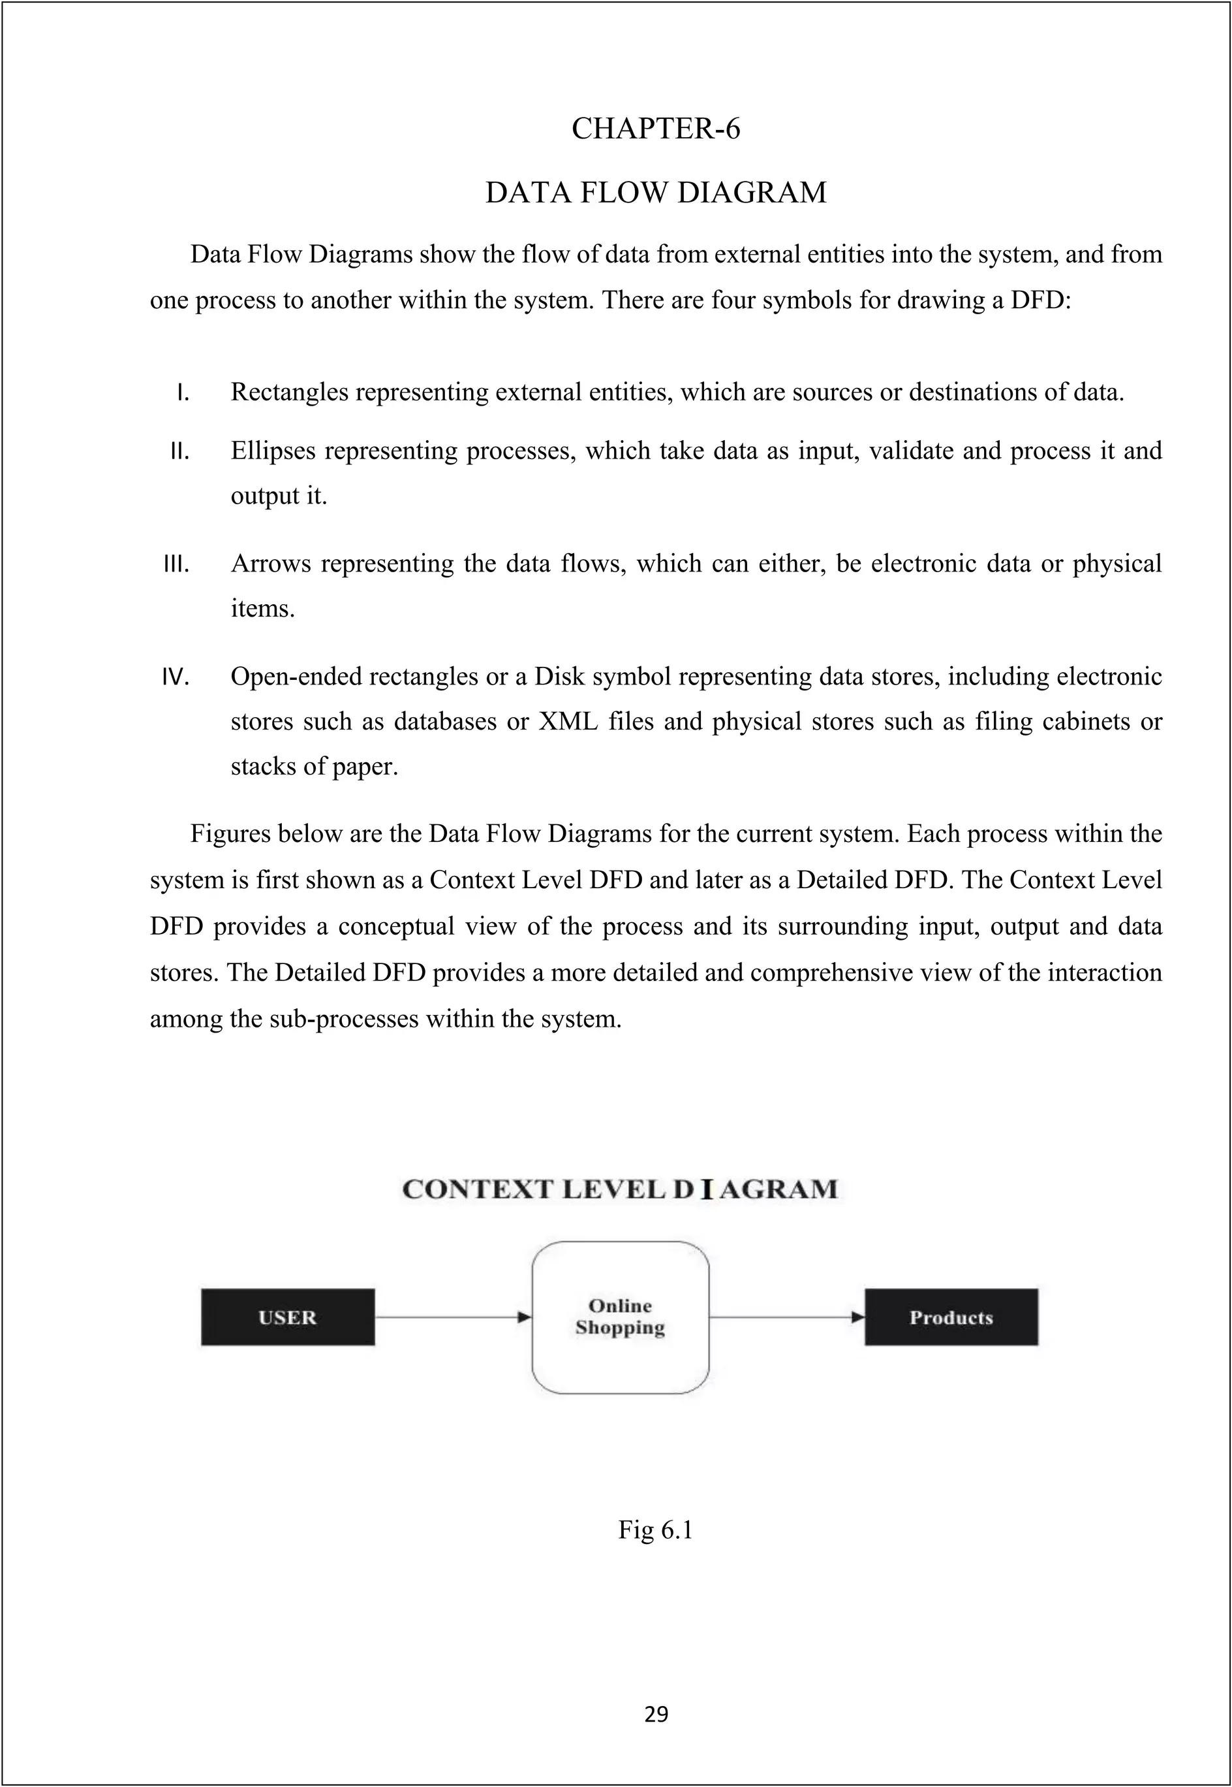

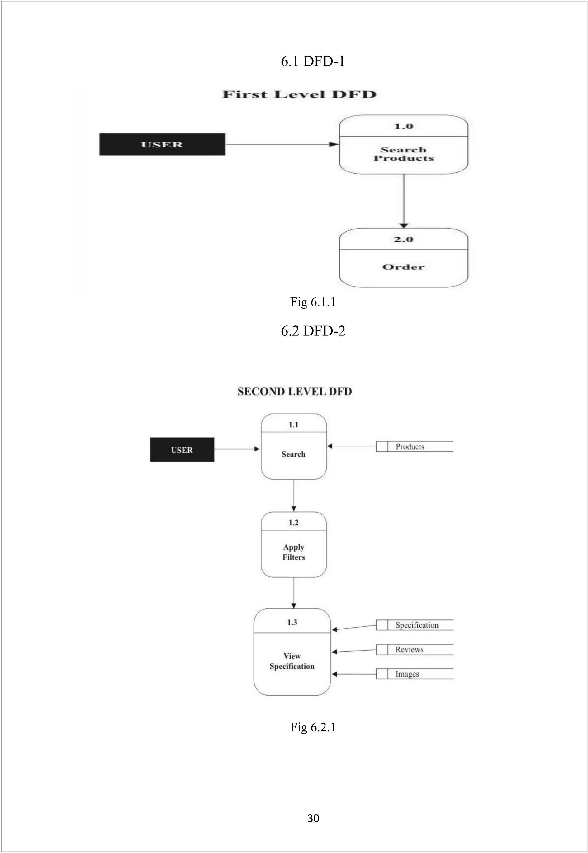

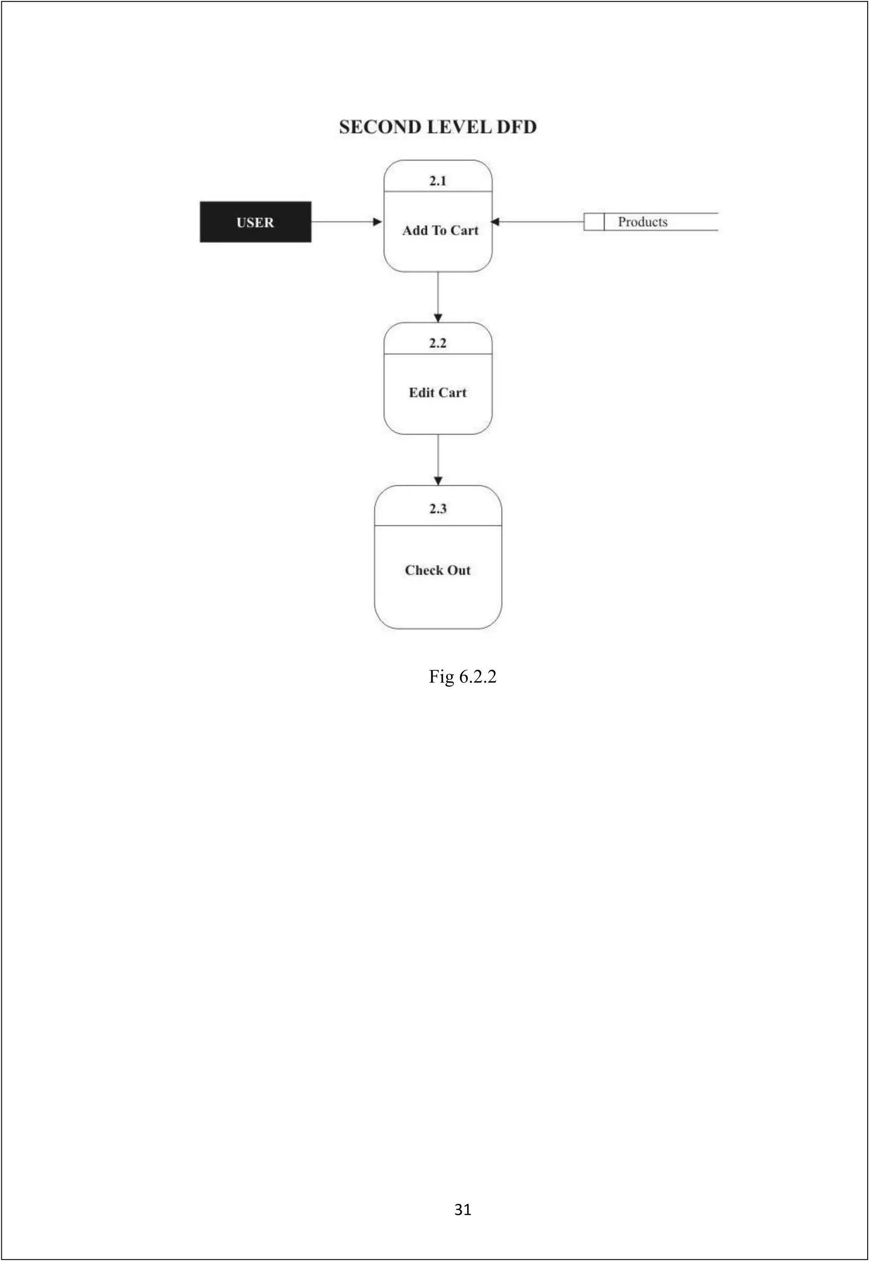

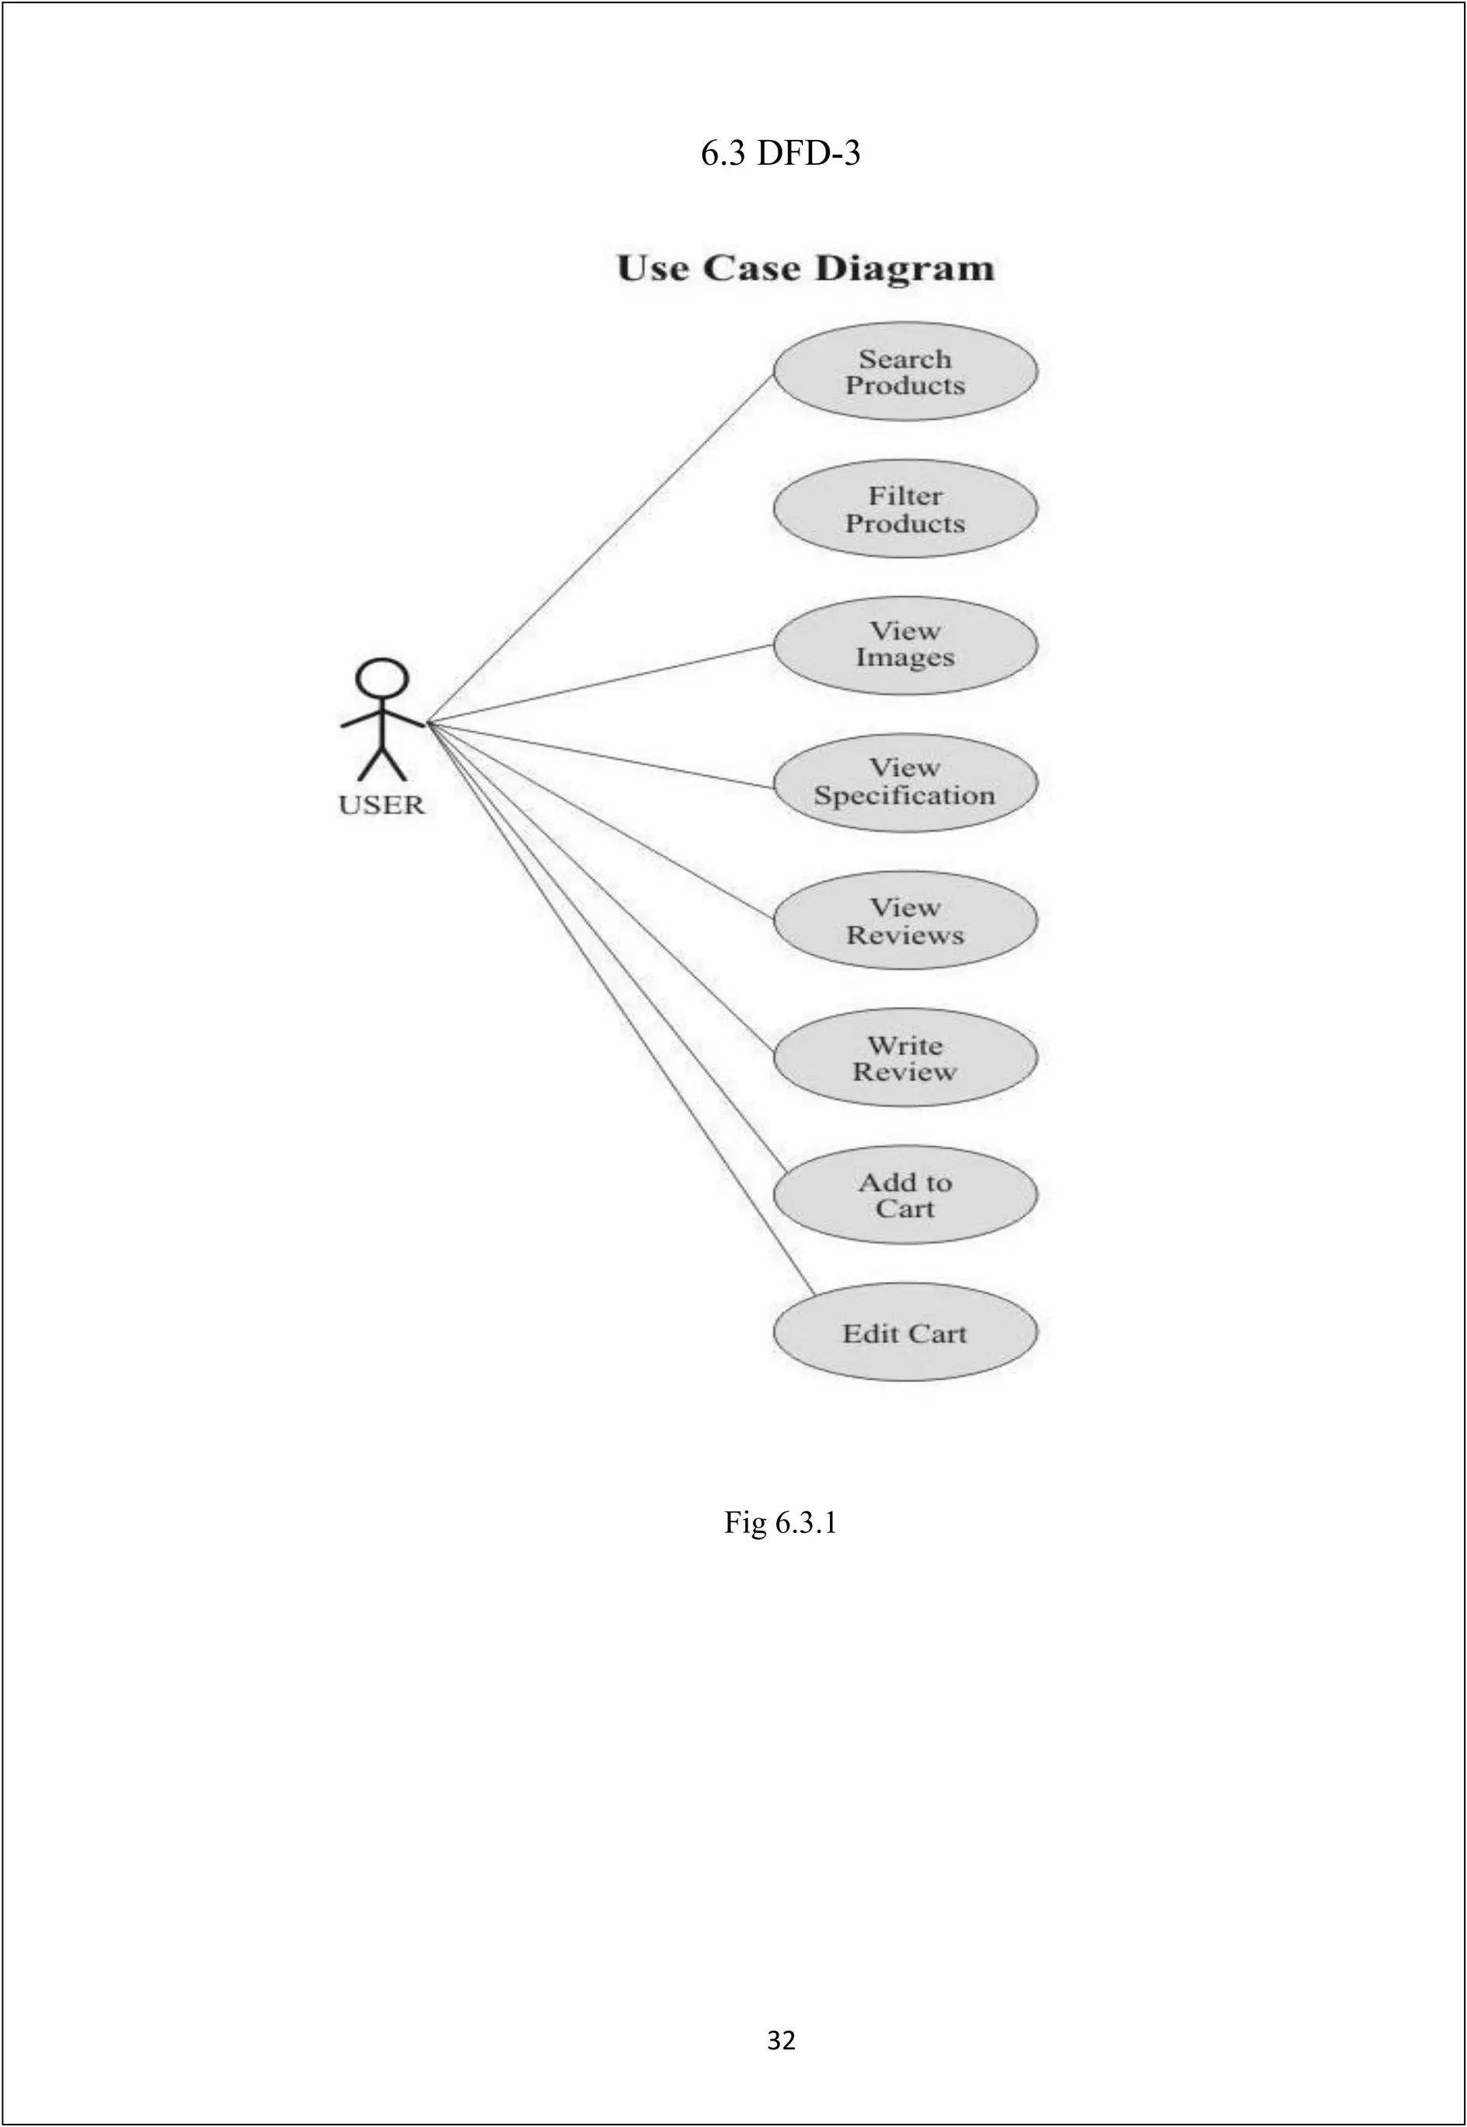

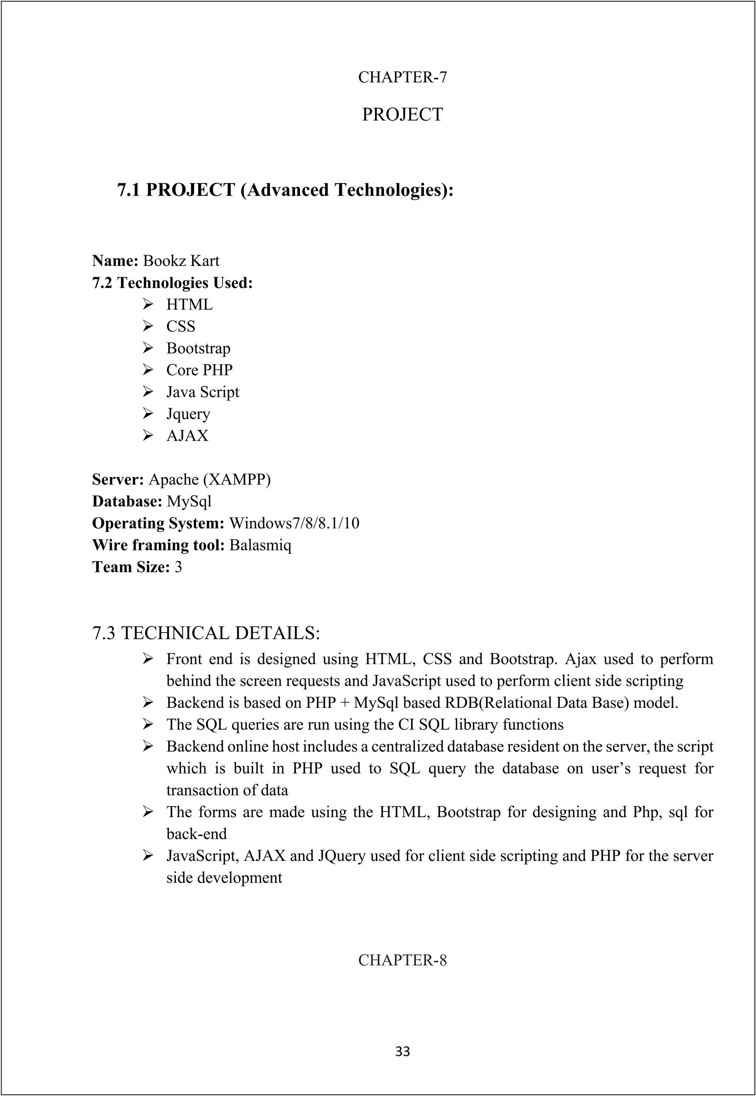

# FRONTEND SCREENSHOTS

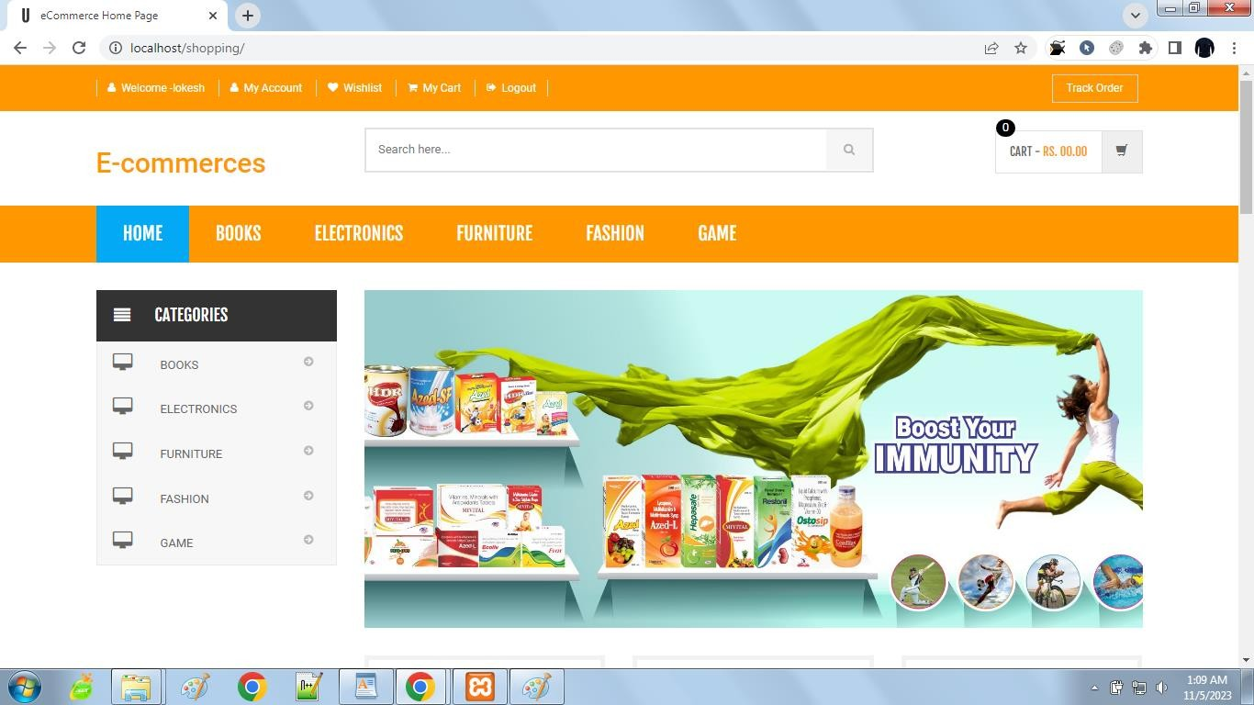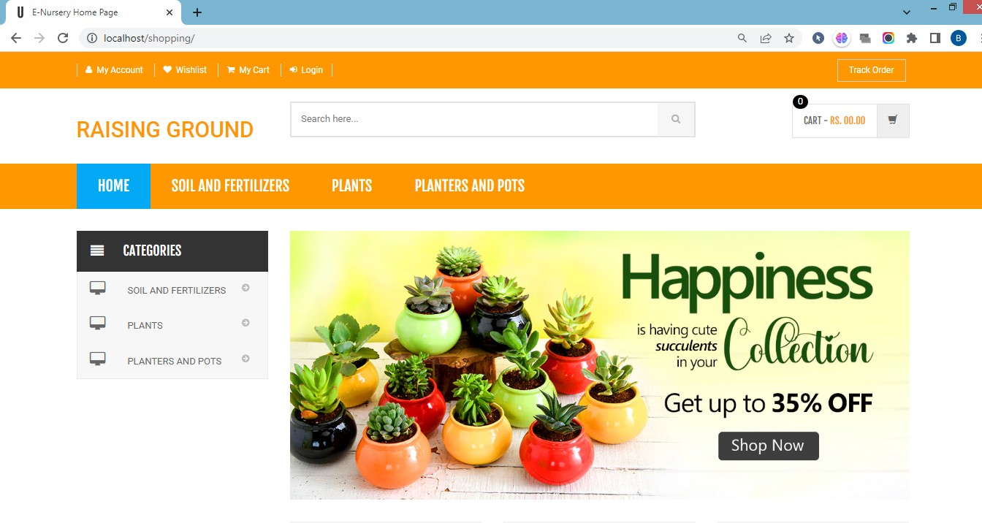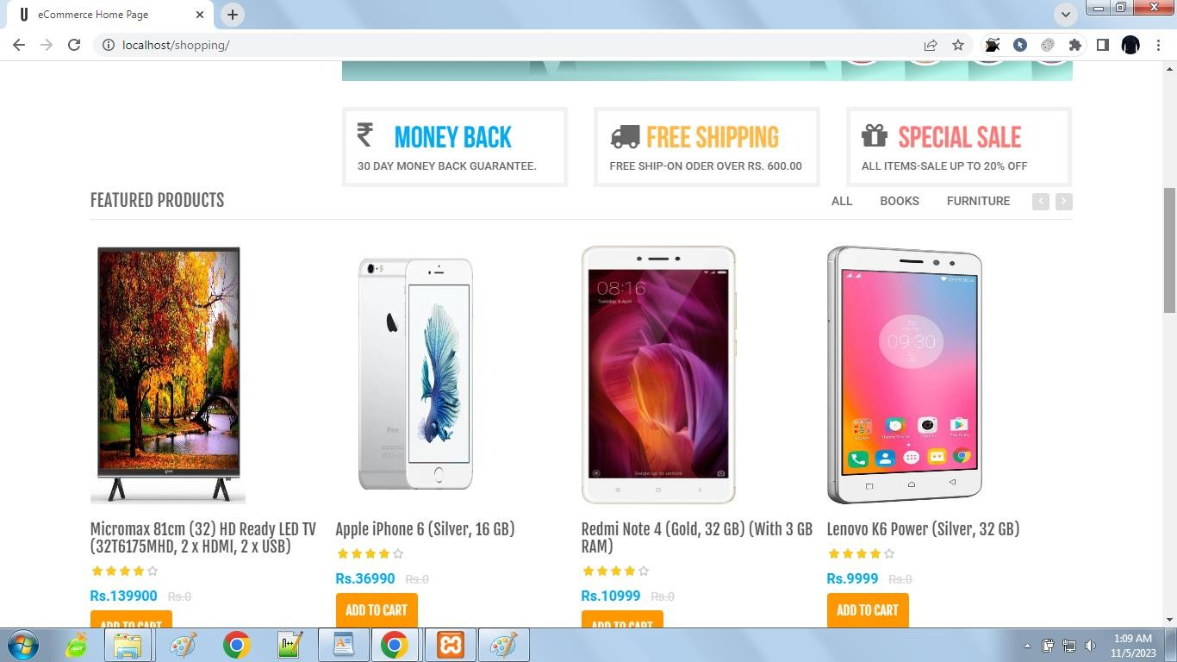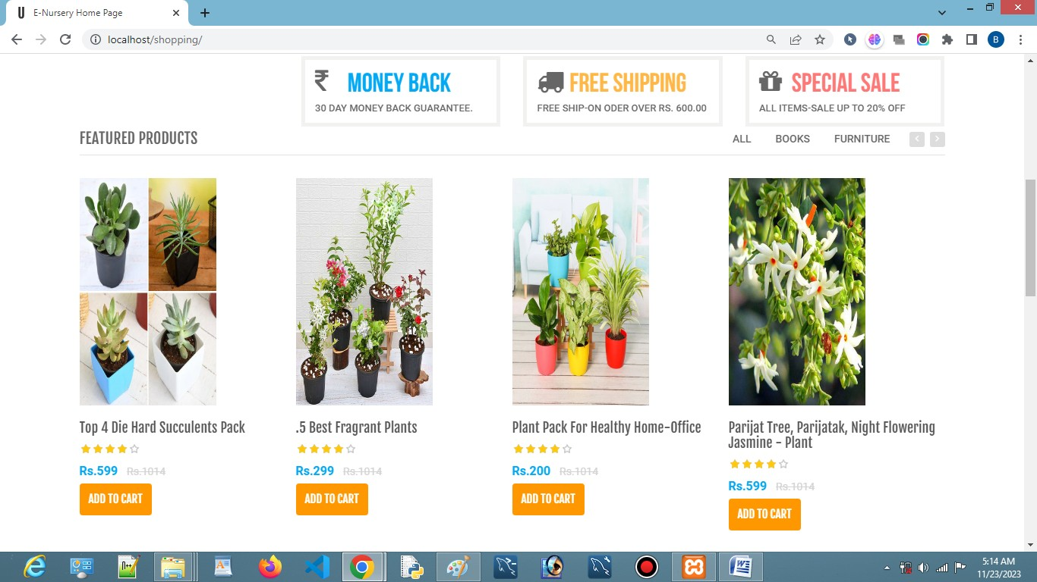

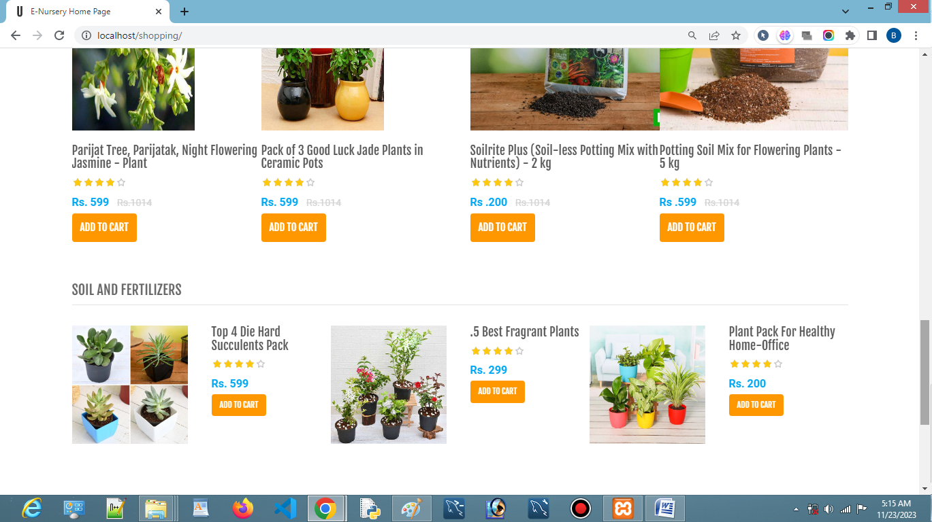

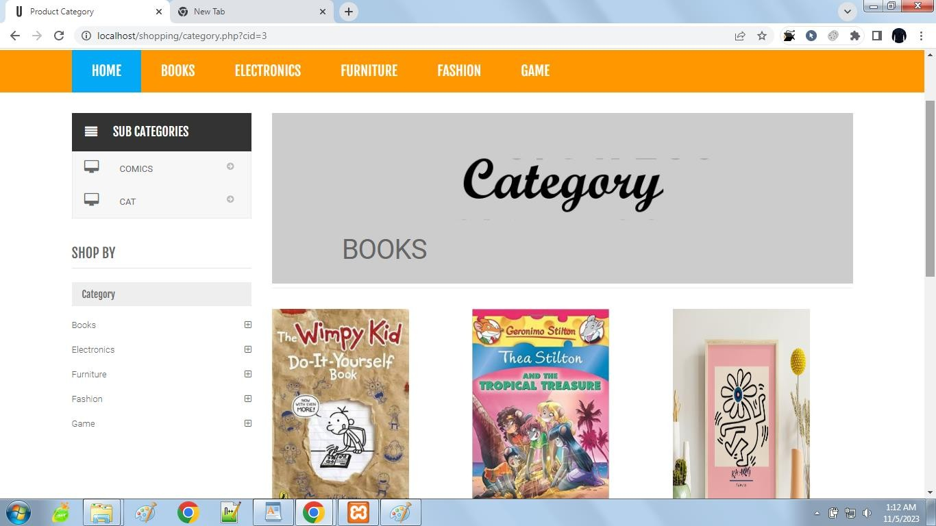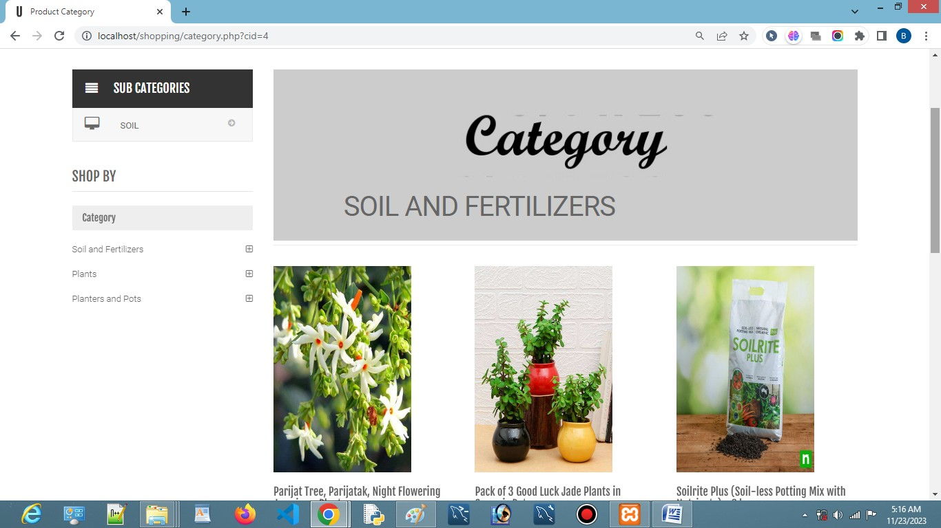

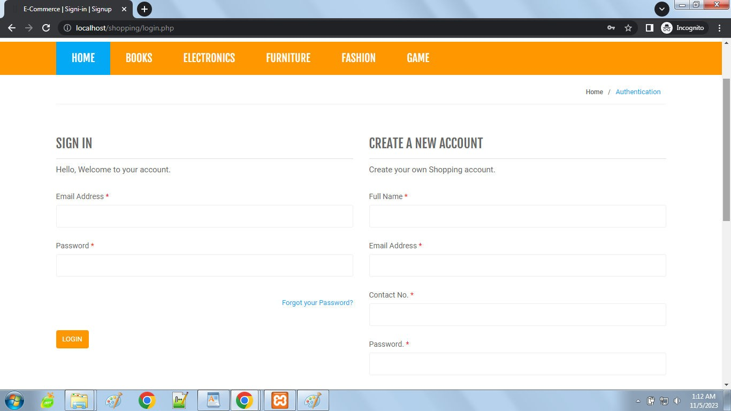

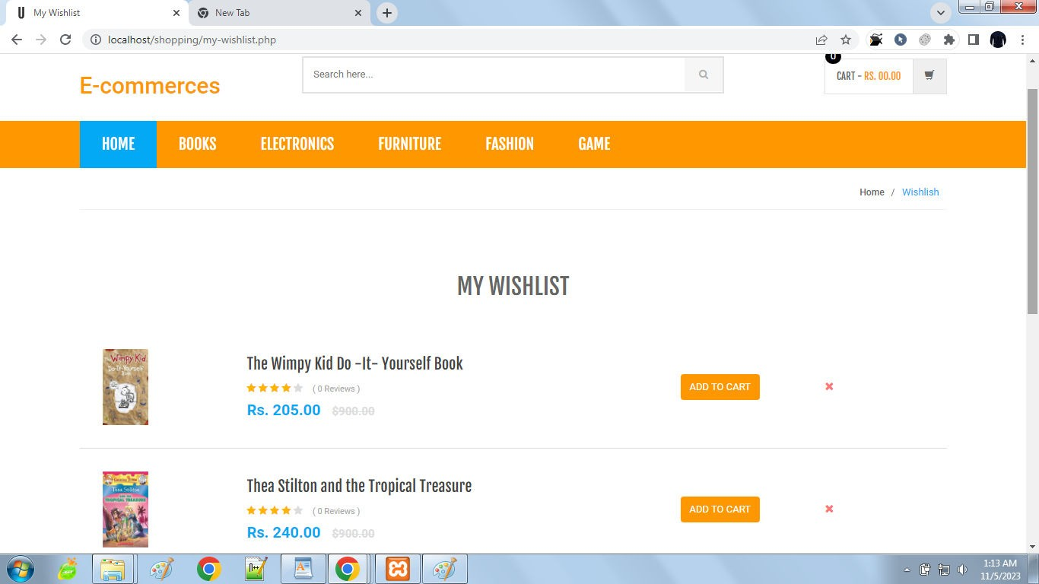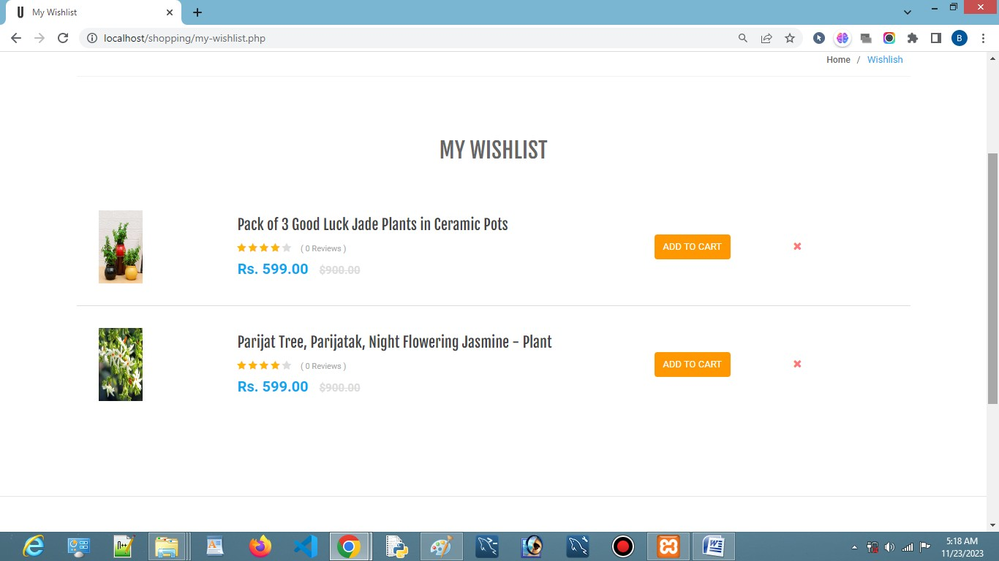

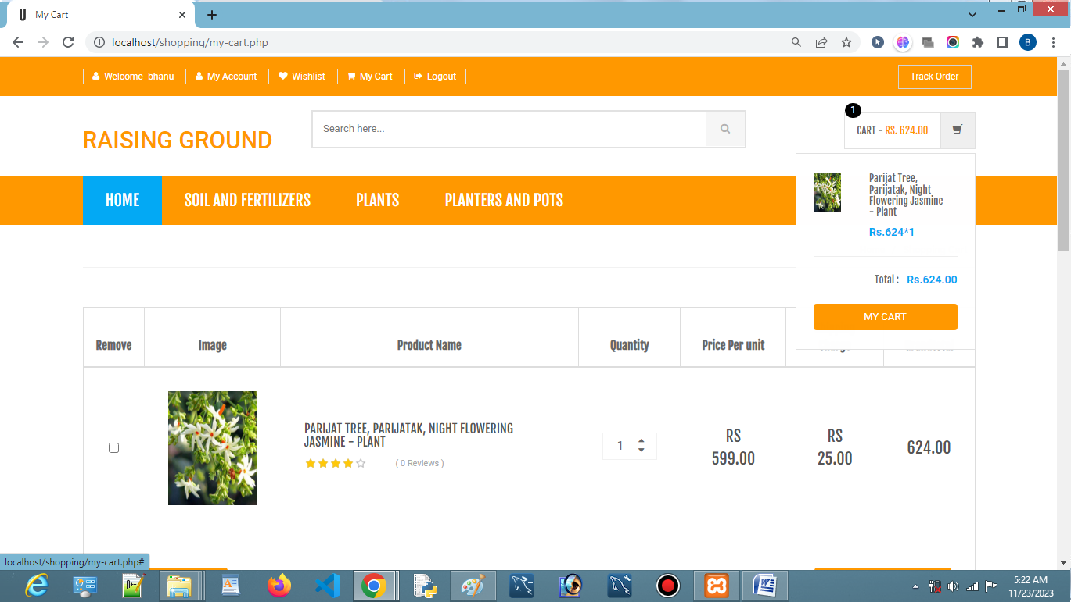

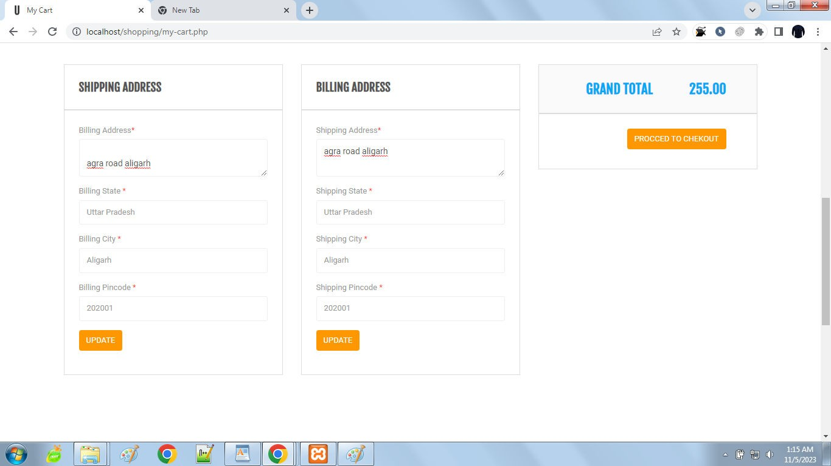

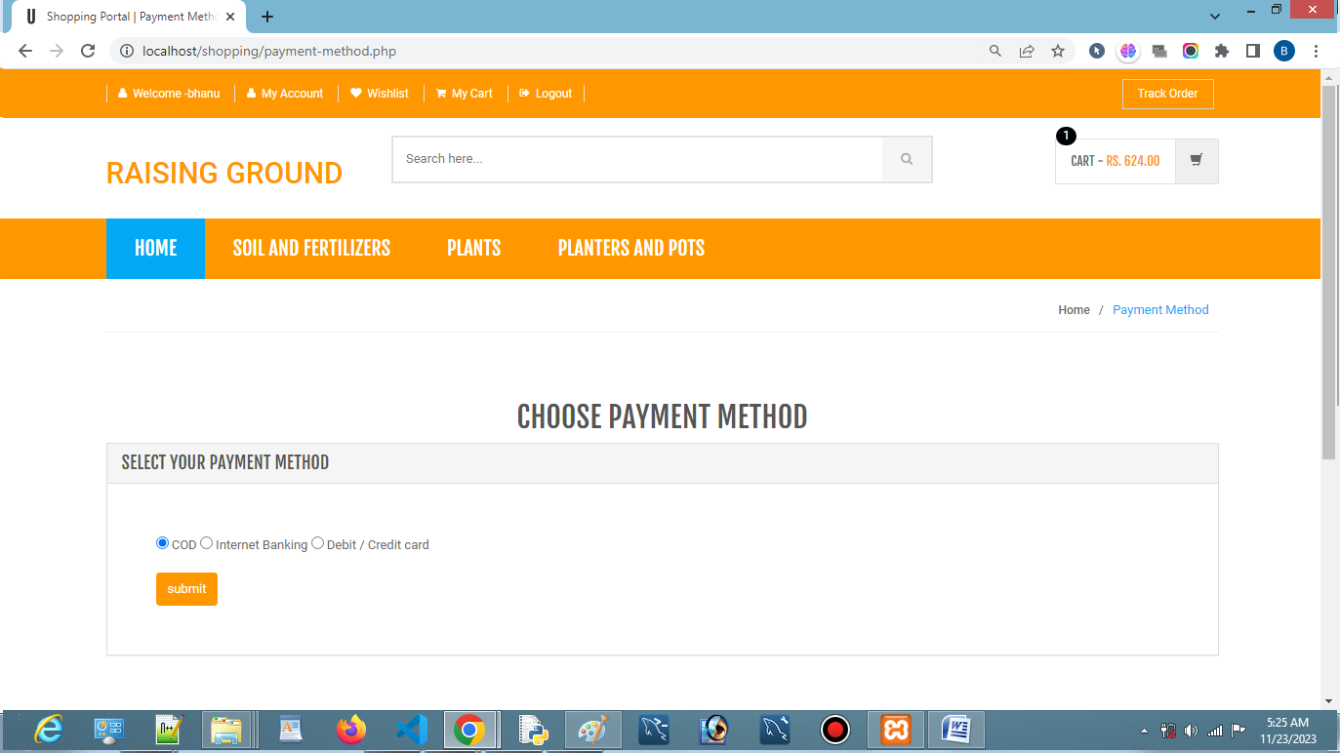

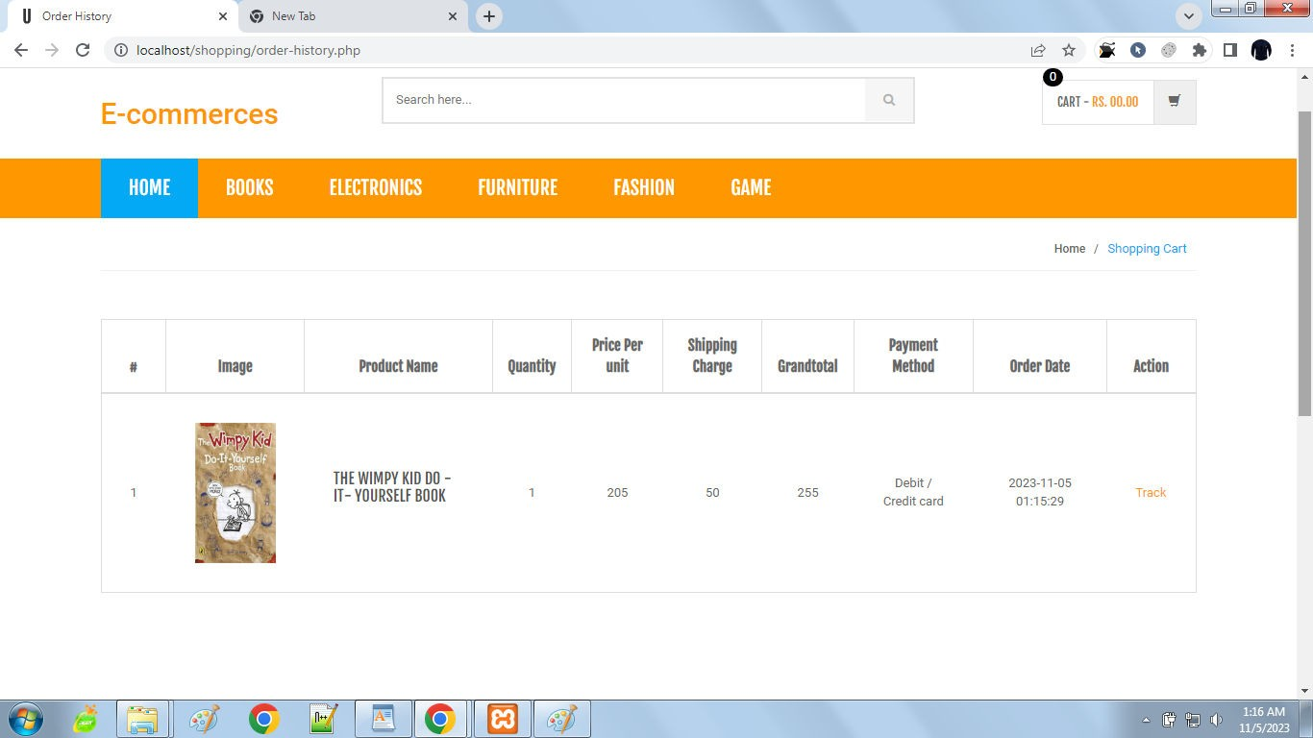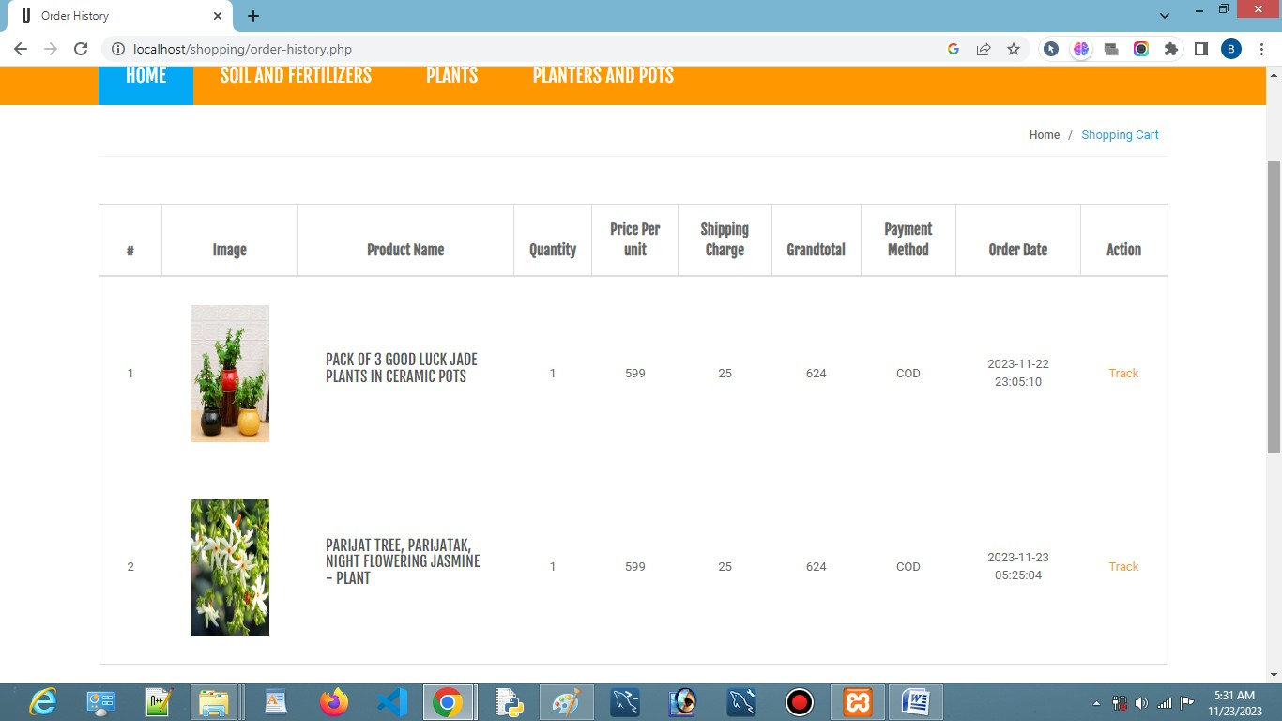

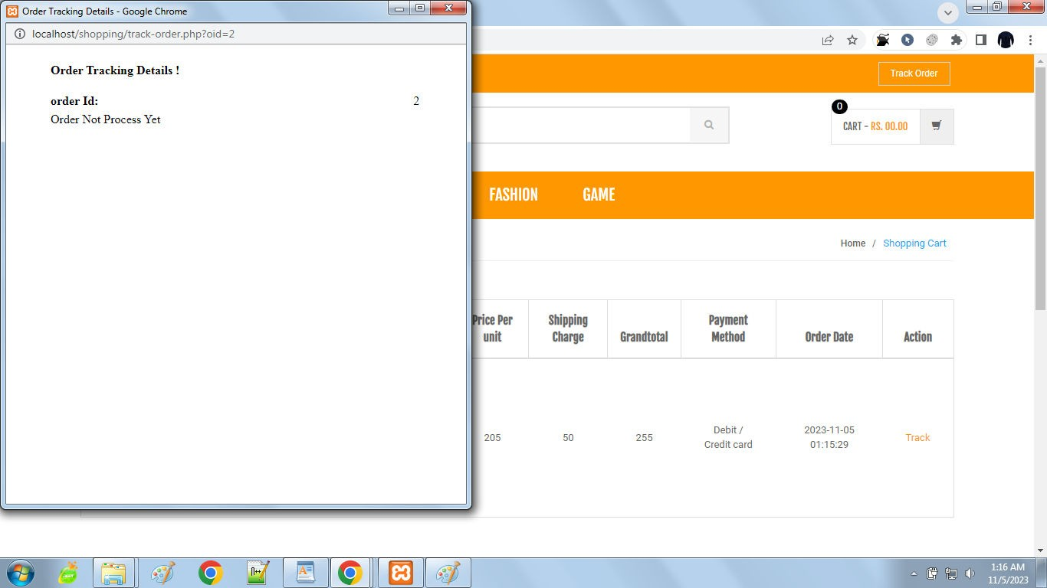

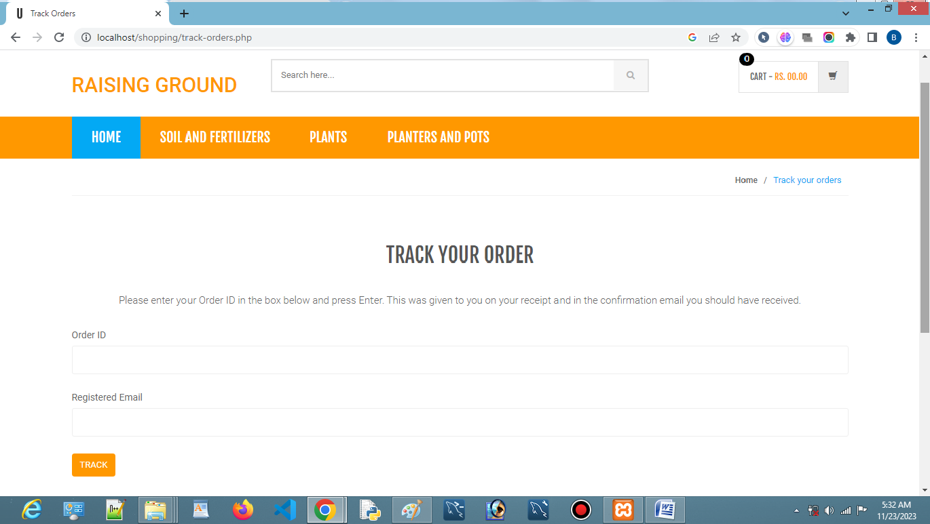

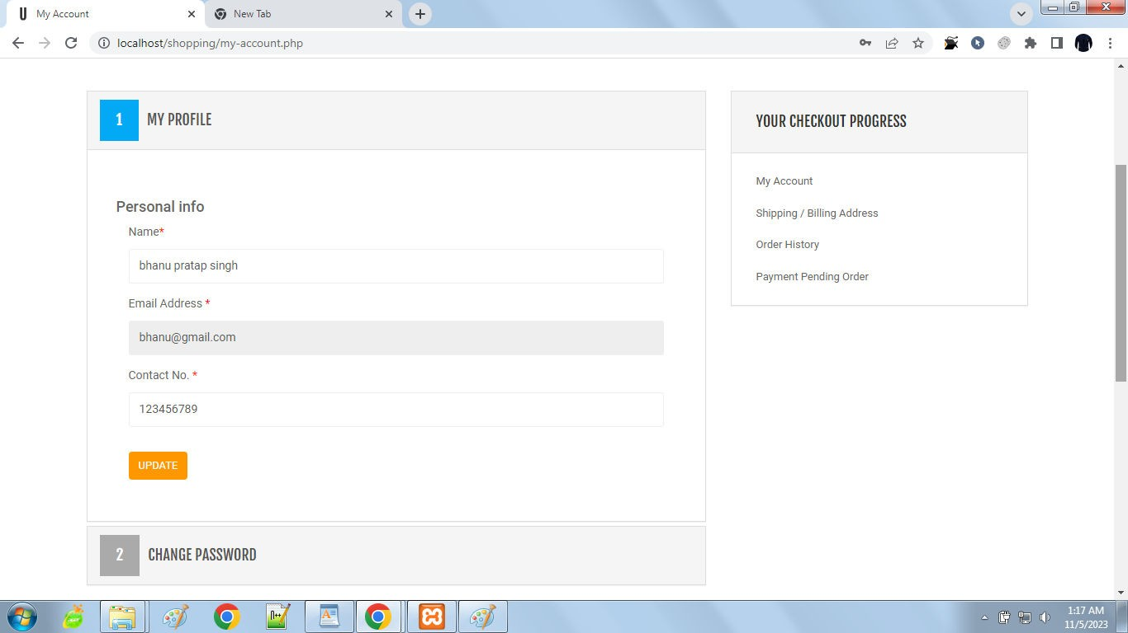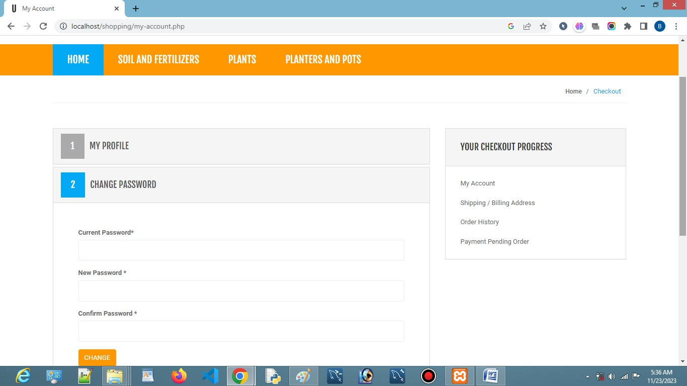

**BACKEND SCREENSHOTS**

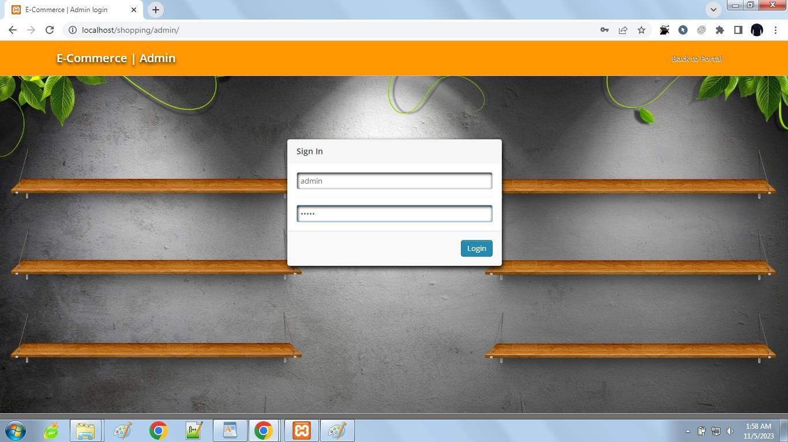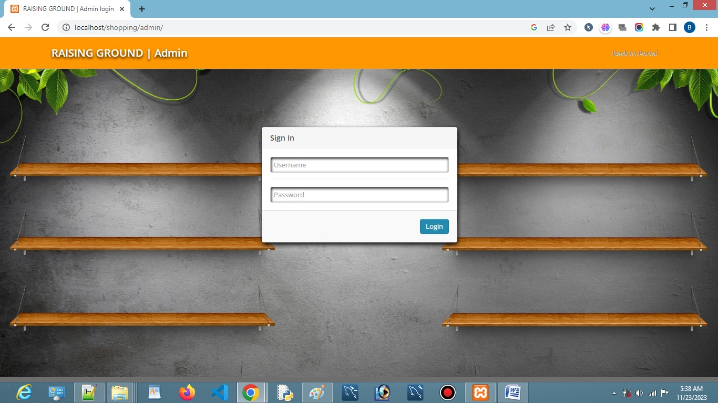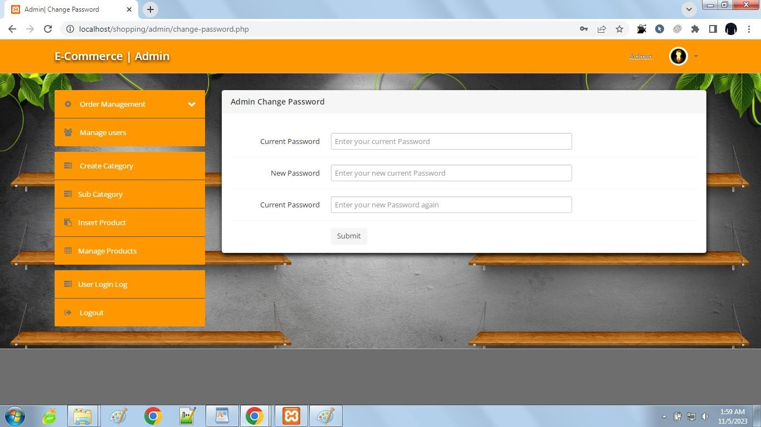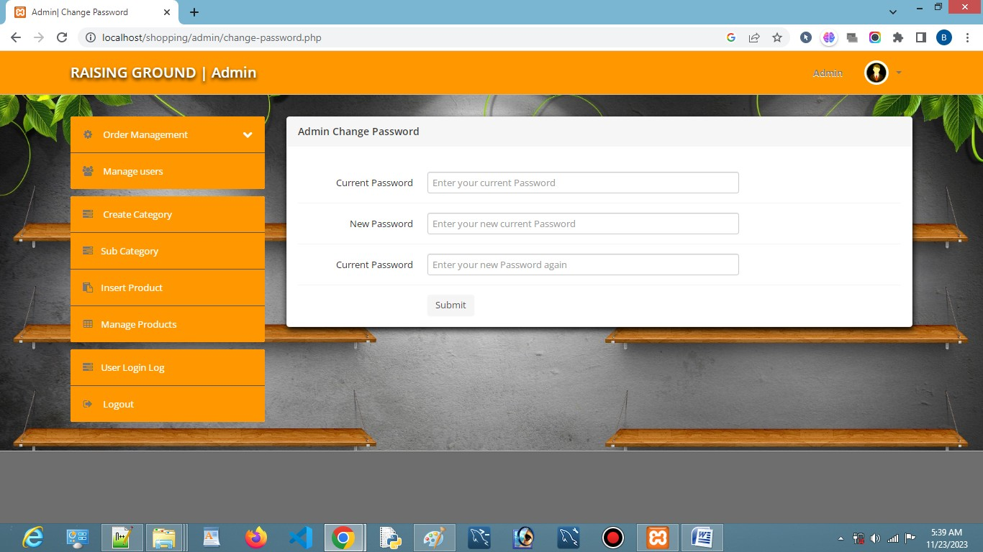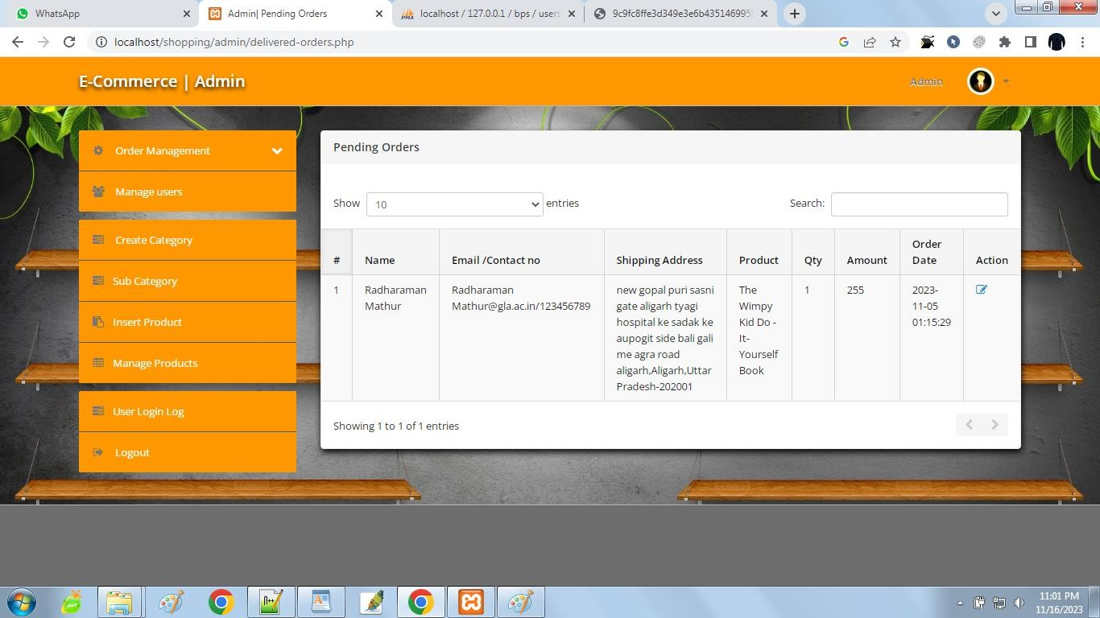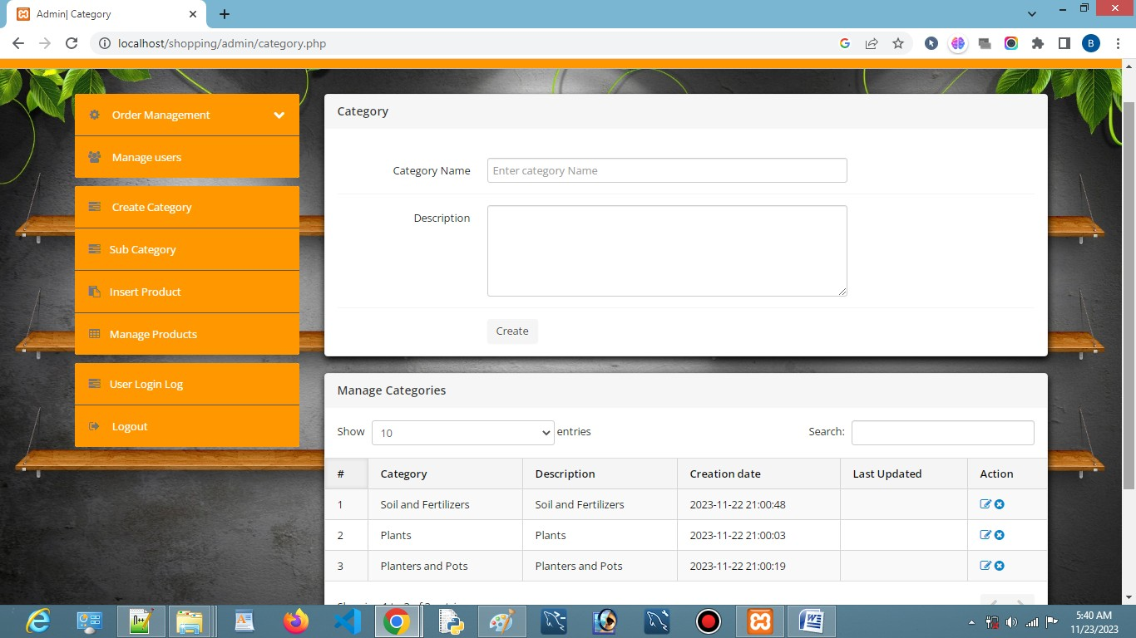

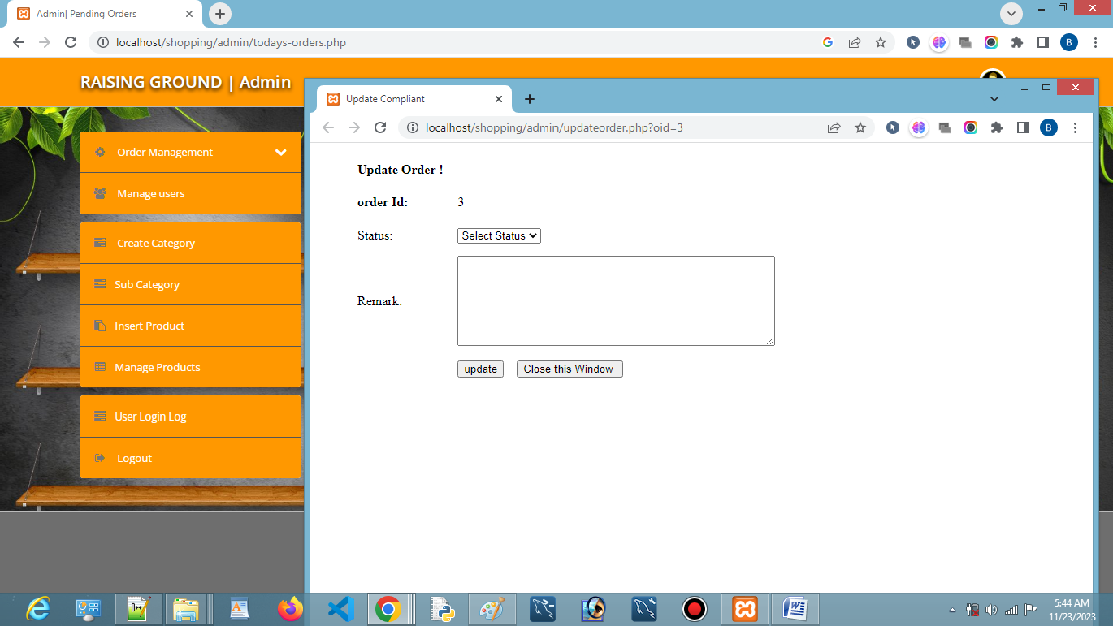

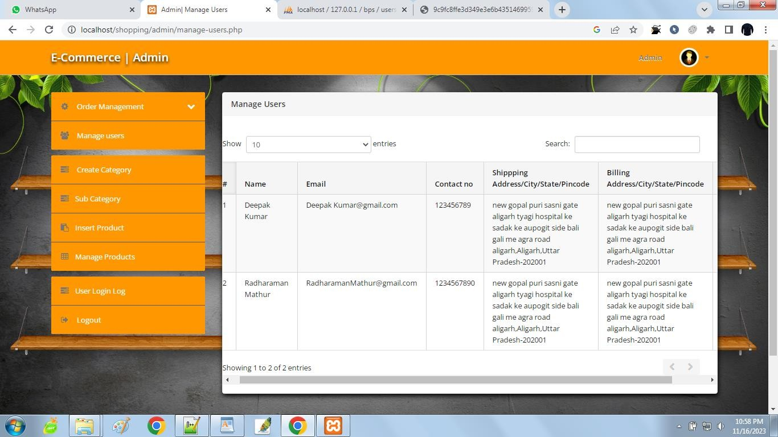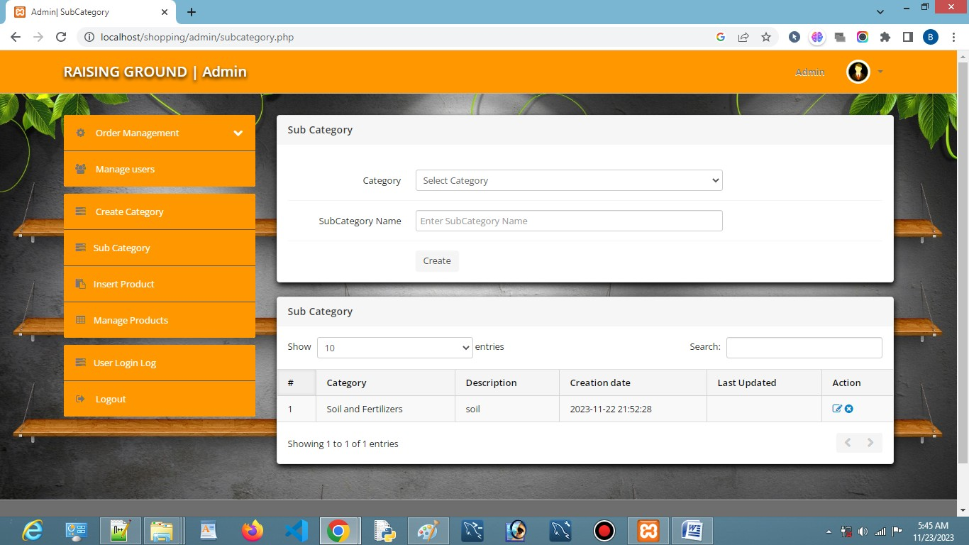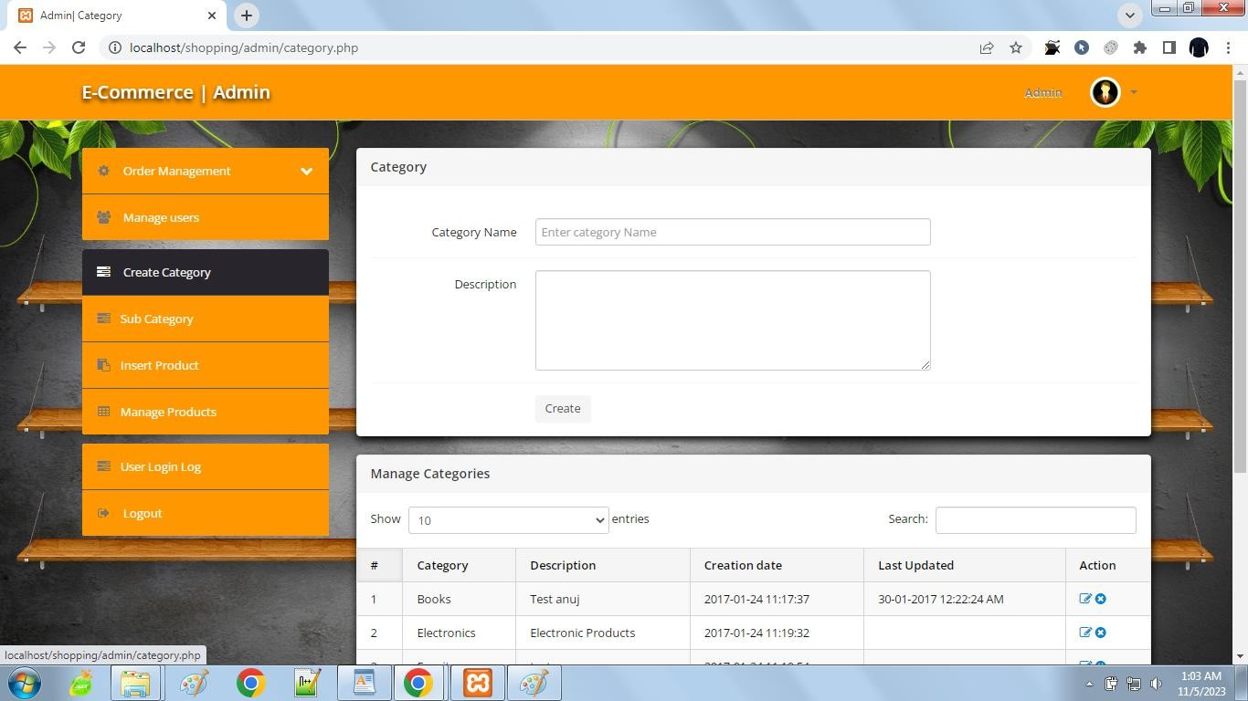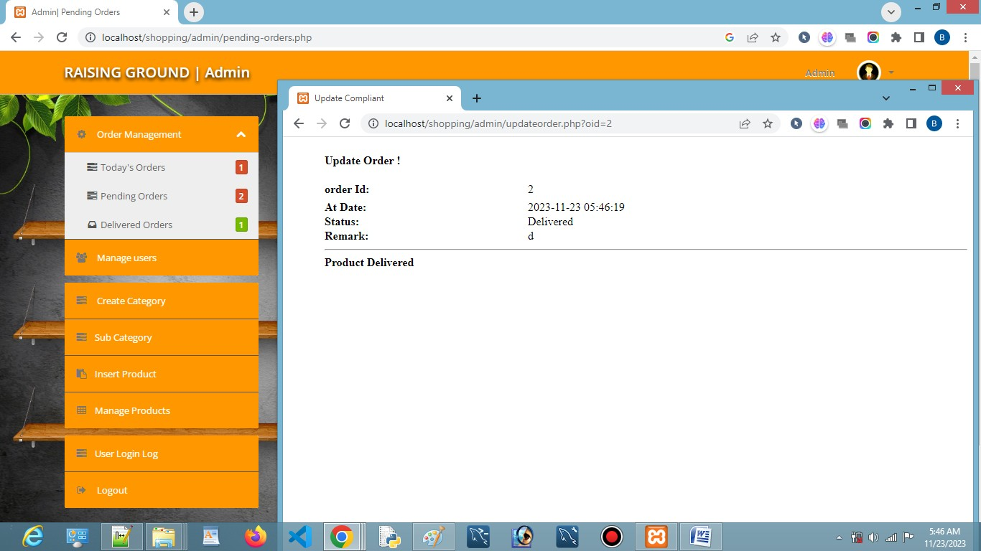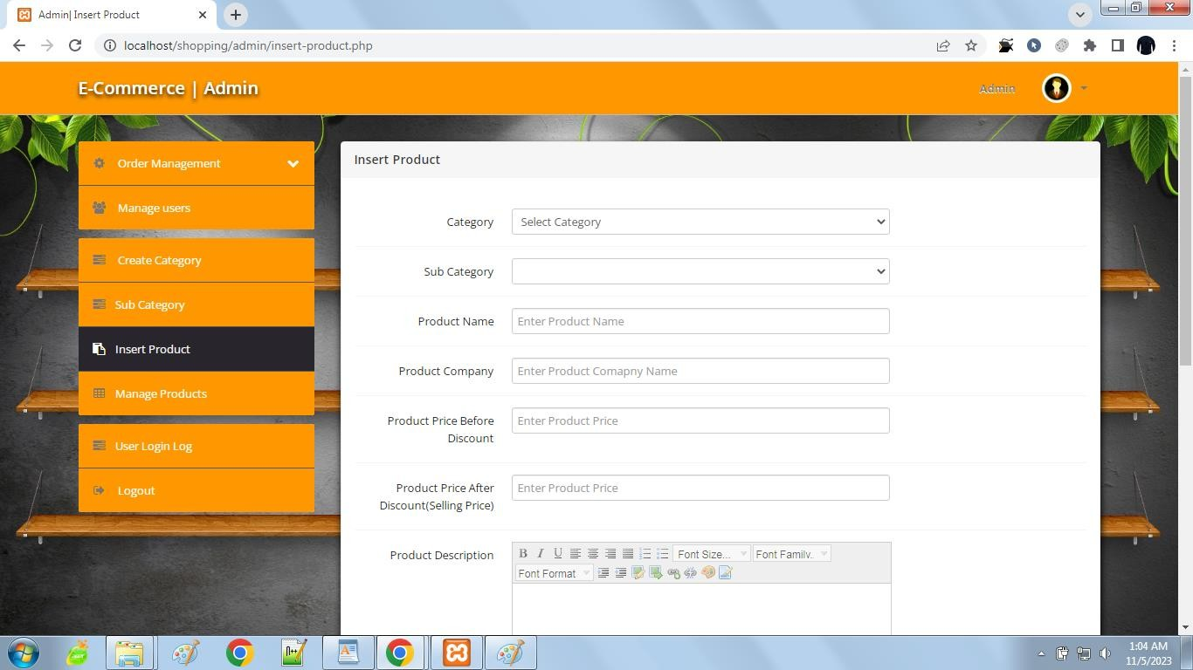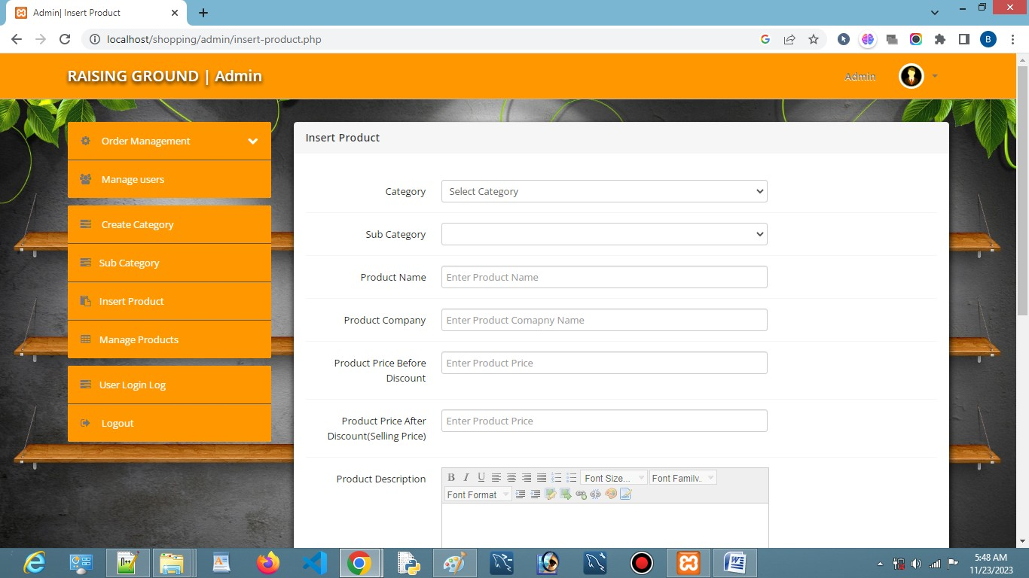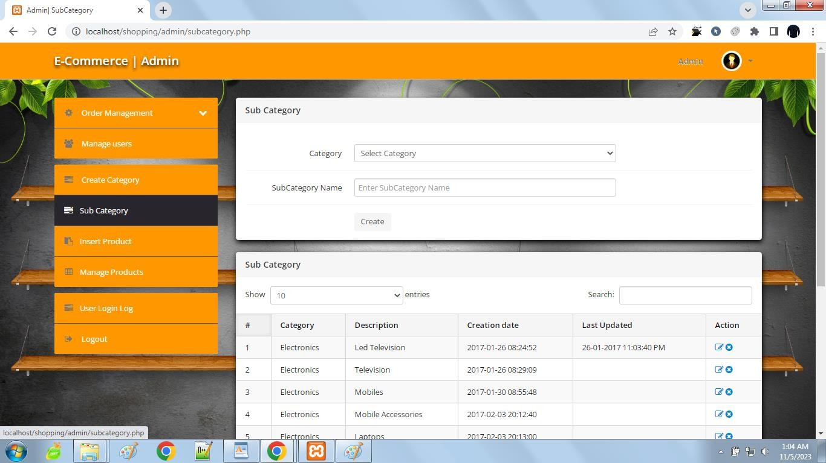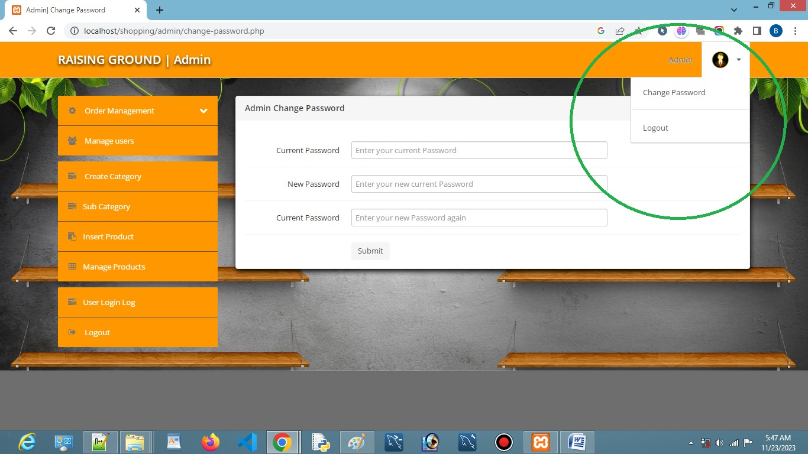

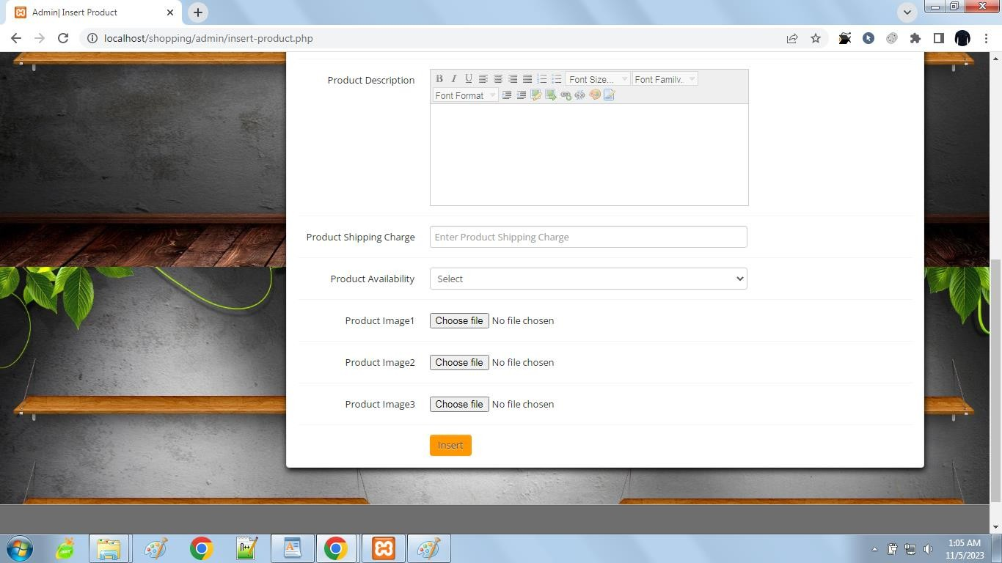

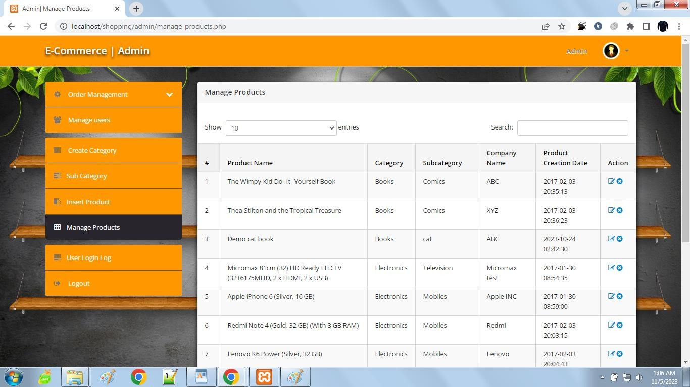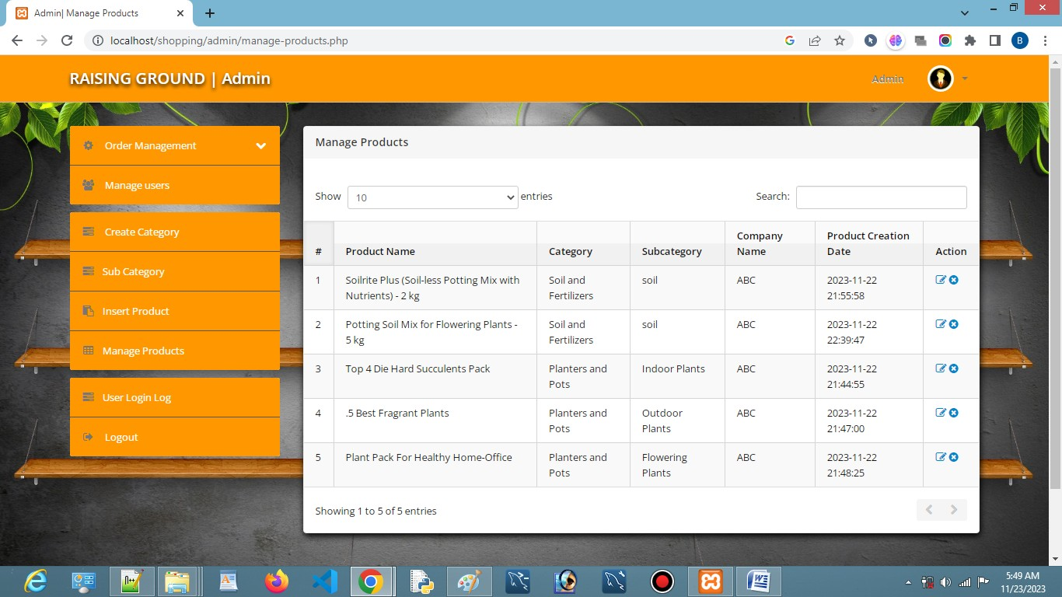

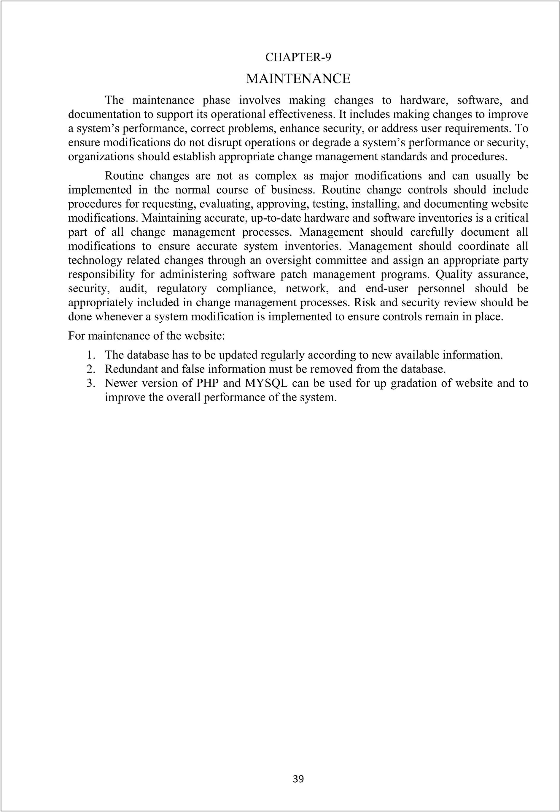

## CHAPTER-10

FUTURE SCOPE & FUTURE ENHANCEMENT

### PROJECT NAME:

**Raising Ground**

1. E-commerce would help each and every person to find any Plant via our website and get it at home, it will save their time.
2. Increasing online shopping is driving the growth online nursery market in the forecast period 2022-2026.

**FUTURE ENHANCEMENT**

* The future work of this project is to improve various categories , add different kinds of payment modes and send order-related updates by E-mail or SMS.

## CHAPTER-11

**CONCLUSION**

We have successfully implemented the site '***E-commerce***'. With the help of various links and tools, we have been able to provide a site which will be live soon and running on the web. We have been successful in our attempt to take care of the needs of both the user as well as the administrator. Finally we hope that this will go a long way in popularizing.

## BIBLIOGRAPHY

1 . https://nurserylive..com

1. www.w3schools. com
2. [www.getbootstrap.com](http://www.getbootstrap.com/)
3. [www.codeigniter.com](http://www.codeigniter.com/)
4. [www.stackoverflow.com](http://www.stackoverflow.com/)
5. [www.fontawesome.io](http://www.fontawesome.io/)
6. [www.php.net](http://www.php.net/)
7. Head first with PHP (Lynn Beighley and Michael Morrison)
8. Learn HTML and CSS faster (Mark Myers)
9. Wikipedia